**Xiang Herbs & Tea**

**About us:**

**Xiang herb and tea a family business include a online organic herb and tea store and orgnic Farm Loganville GA**.Our family have 3 generation herbalists. In the online store we sell only USDA certified organic herb and tea . In our organic farm we grow diverse seasonal herbs and flowers year round which we sell to local customers. In addition to our herbs, we raise chicken and geese.

**We strive to provide our the produts as good as for ourself.**

**Why organic:**

**Certified organic tea is free of synthetic fertilizers, herbicides, and pesticides. Organic farming sustains the health of soils, ecosystems and people. It relies on ecological processes, biodiversity and cycles adapted to local conditions, rather than the use of inputs with adverse effects. Organic farming combines tradition, innovation and science to benefit the shared environment and promote fair relationships and a good quality of life for all involved.**

Teas that are not certified organic are often air dried without rinsing, meaning that synthetic chemicals are dried on the leaf, and may end up in your cup. This can affect the quality of the tea and pose potential health risks.

in addition, synthetic chemicals are designed to stimulate production. While these methods may increase the yield of a crop, there is a cost of quality. An organic tea grower uses more natural processes to create a sustainable yield. These practices are reflected in the flavor of the tea, and a better nutritional content.

Synthetic fertilizers play a major role in contaminating the environment. A relatively small amount of the nitrogen contained in fertilizers applied to the soil is actually absorbed by plants. The rest runs off into waterways, where it creates massive “algal blooms.” The overgrown nitrate-fed algae starve water of oxygen, suffocating fish and other aquatic life. Runoff nitrogen also leaches into groundwater, contaminating drinking water and creating widespread health hazards.Pesticide use raises a number of environmental concerns. Over 98% of sprayed insecticides and 95% of herbicides reach a destination other than their target species, including non-target species, air, water and soil. Pesticide drift occurs when pesticides suspended in the air as particles are carried by wind to other areas, potentially contaminating them. Pesticides are one of the causes of water pollution, and some pesticides are persistent organic pollutants and contribute to soil contamination.

In addition, pesticide use reduces biodiversity, reduces nitrogen fixation, contributes to pollinator decline, destroys habitat (especially for birds), and threatens endangered species.

Also visit [**https://livingmaxwell.com/why-drink-organic-tea**](https://livingmaxwell.com/why-drink-organic-tea)

**Our organic product:**

**Loose leaf tea**

**Green**

**Black**

**White**

**Chai**

**Oolong**

**Herbal Wellness teas**

**Cold & Defence**

**Detox & Digestion**

**Sleep & Relaxation**

**Alertness & Focus**

**Hydration & Glow**

**Tea Ware:**

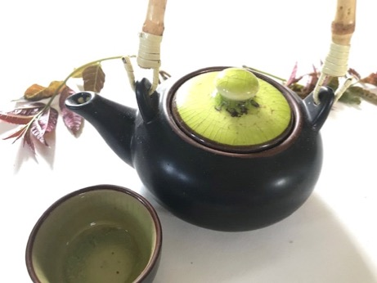

**Packaging:** To preserve freshness, aroma, and potency, our herb and teas are packaged in a polyfoil bag with a re-sealable zipper closure, protecting the contents from light exposure and moisture.

**The following are the products we sell:**

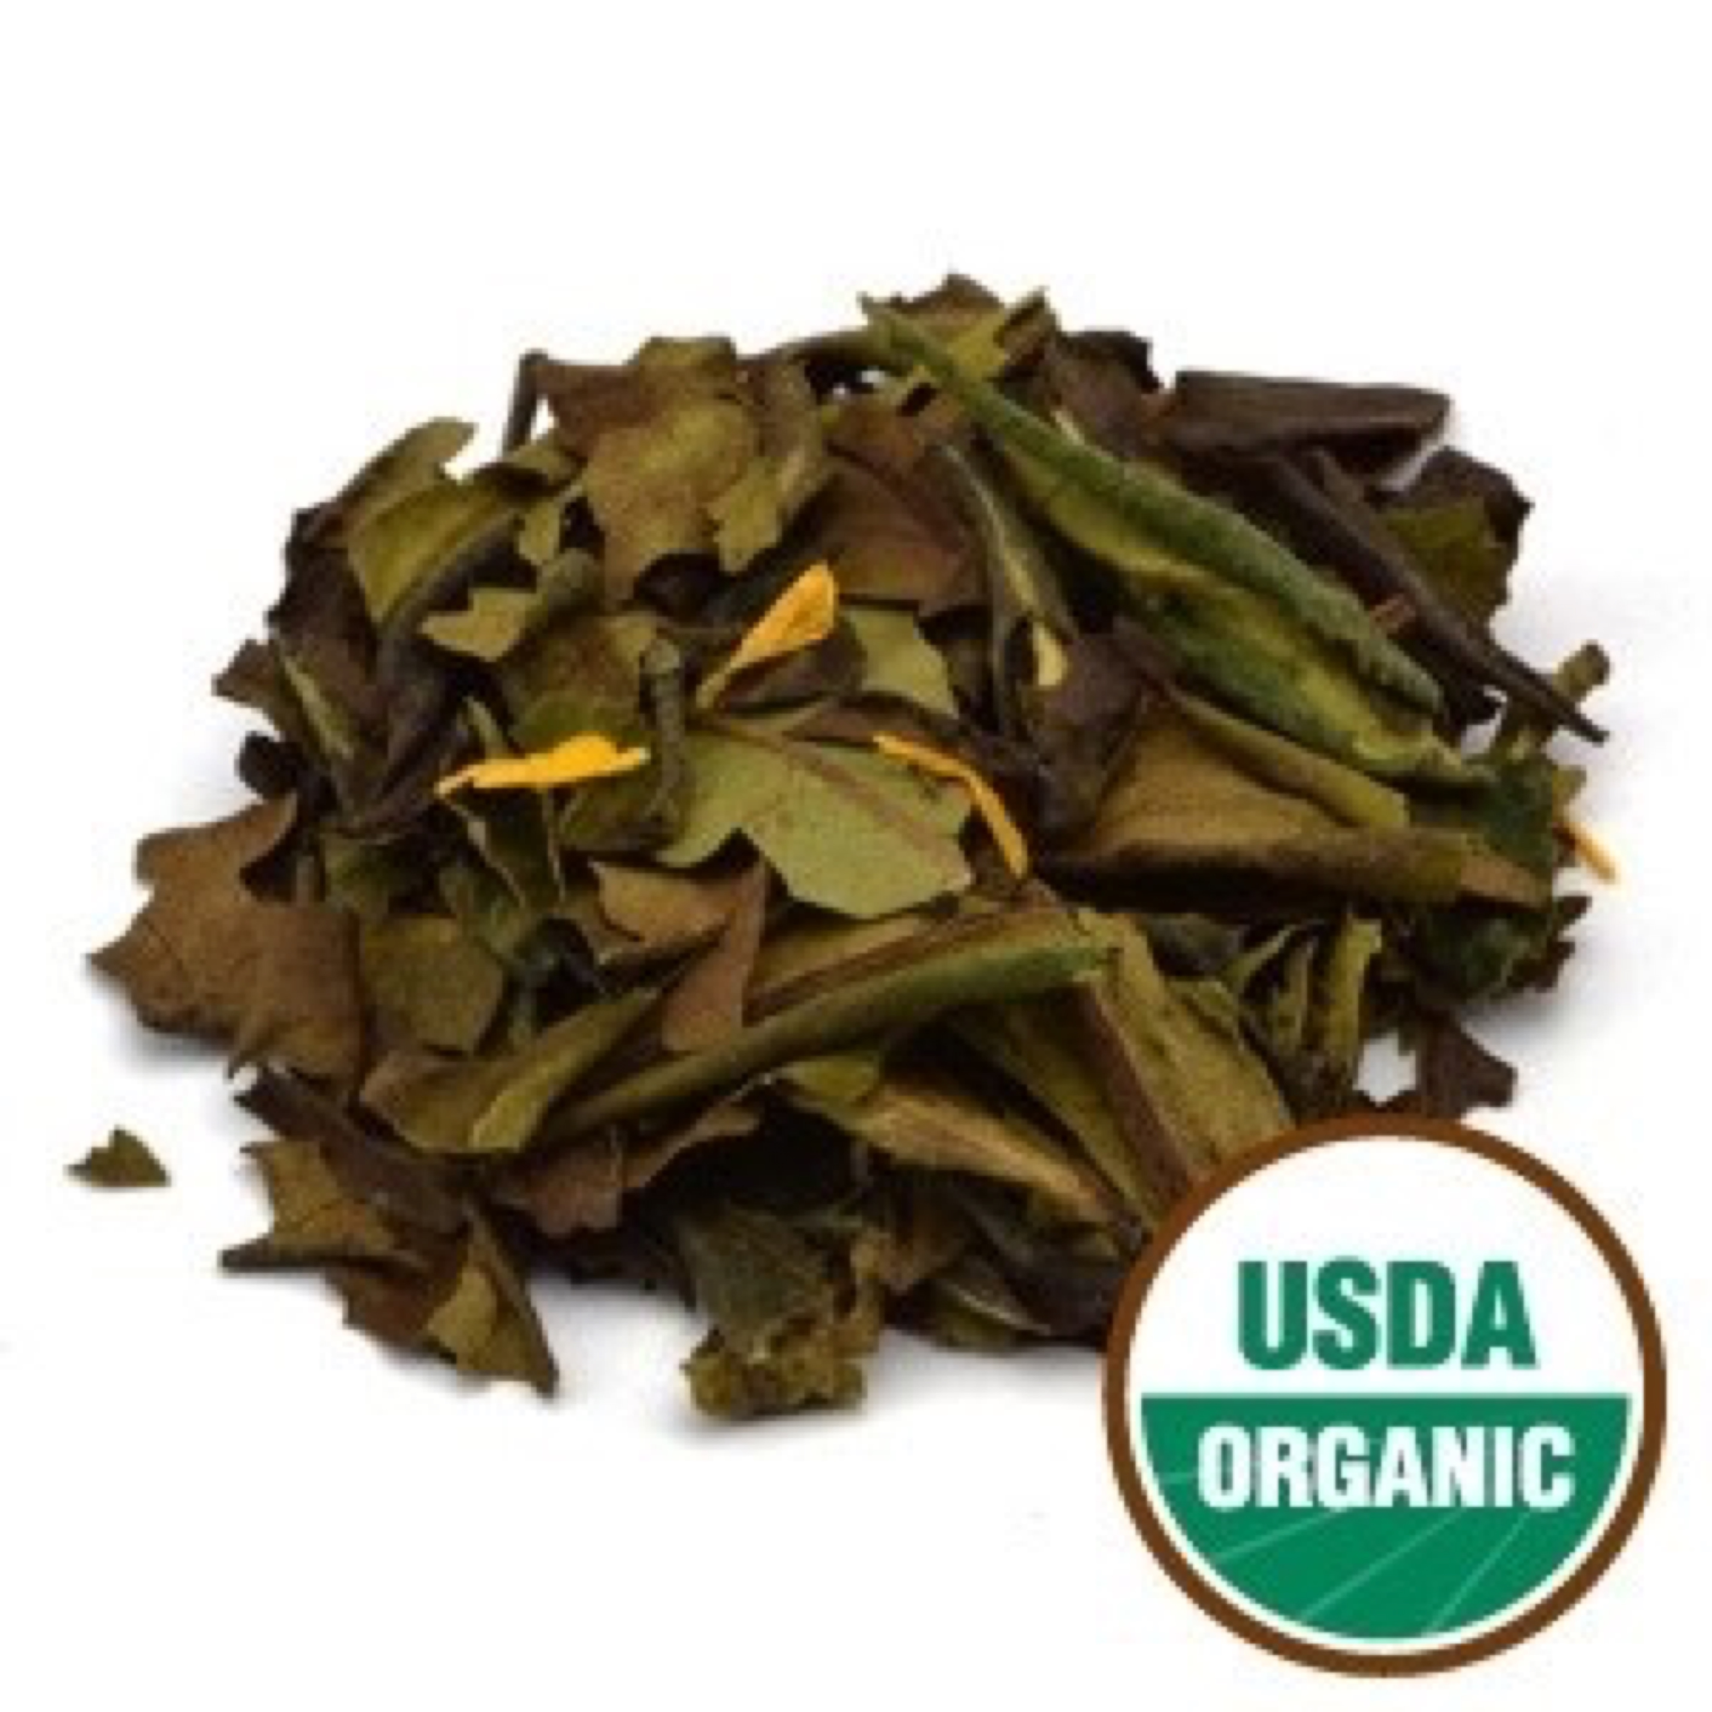

White

Peach Flavored White Tea Organic

Refreshing peach flavor is combined with our delicate, naturally sweet premium white tea, giving this tea the pleasant aroma and taste of sweet ripened peaches with a peach-nectar aroma. It has a delicate and light fruity flavor, and makes an invigorating and refreshing white tea! Milk and sugar complement this tea well, and it’s perfect either hot or served as a chilled iced tea.

Ingredients: Organic Shu Mee White Tea and organic flavor.

Daily serving size: Pour 8 oz of simmering water (185-195° F preferred) over 1 tsp. of tea. Steep 3-4 minutes.

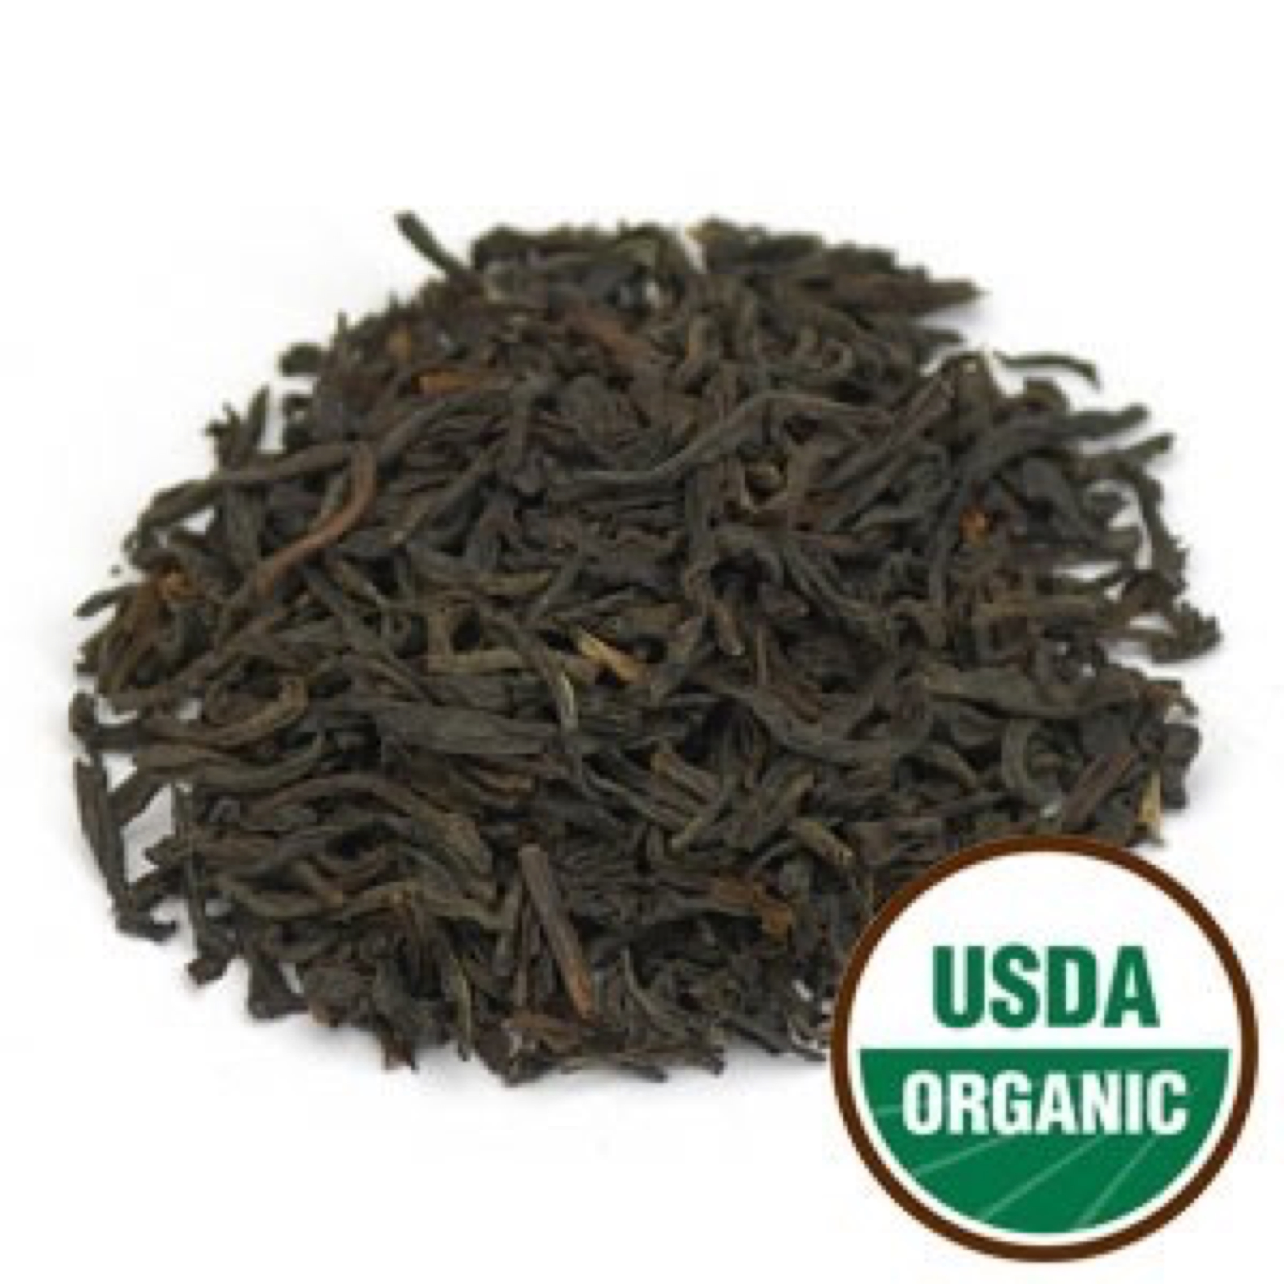

**Assam T.G.F.O.P. Tea Organic Black**

Botanical Name: Camellia sinensis

Origin: India

size : 4 oz, 1 lb

An Organic Assam Black Tea from the mountains of southern India. T.G.F.O.P. is a very high grade tea, containing many lighter golden tan tips of the tea adding to the depth of taste. This tea has a full-bodied, rich malty flavor and makes a delicious breakfast tea. Milk and sugar complement this tea well.

Tippy Golden Flowery Orange Pekoe (T.G.F.O.P.) is FOP with a larger amount of tips. When these tips are in abundance, the terms 'Tippy and Golden' are attached to FOP, thus making it Tippy Golden Flowery Orange Pekoe. TGFOP is the top grade of OP tea.

Daily serving size: Pour 8 oz of simmering water (185-195° F preferred) over 1 tsp. of tea. Steep 3-4 minutes.

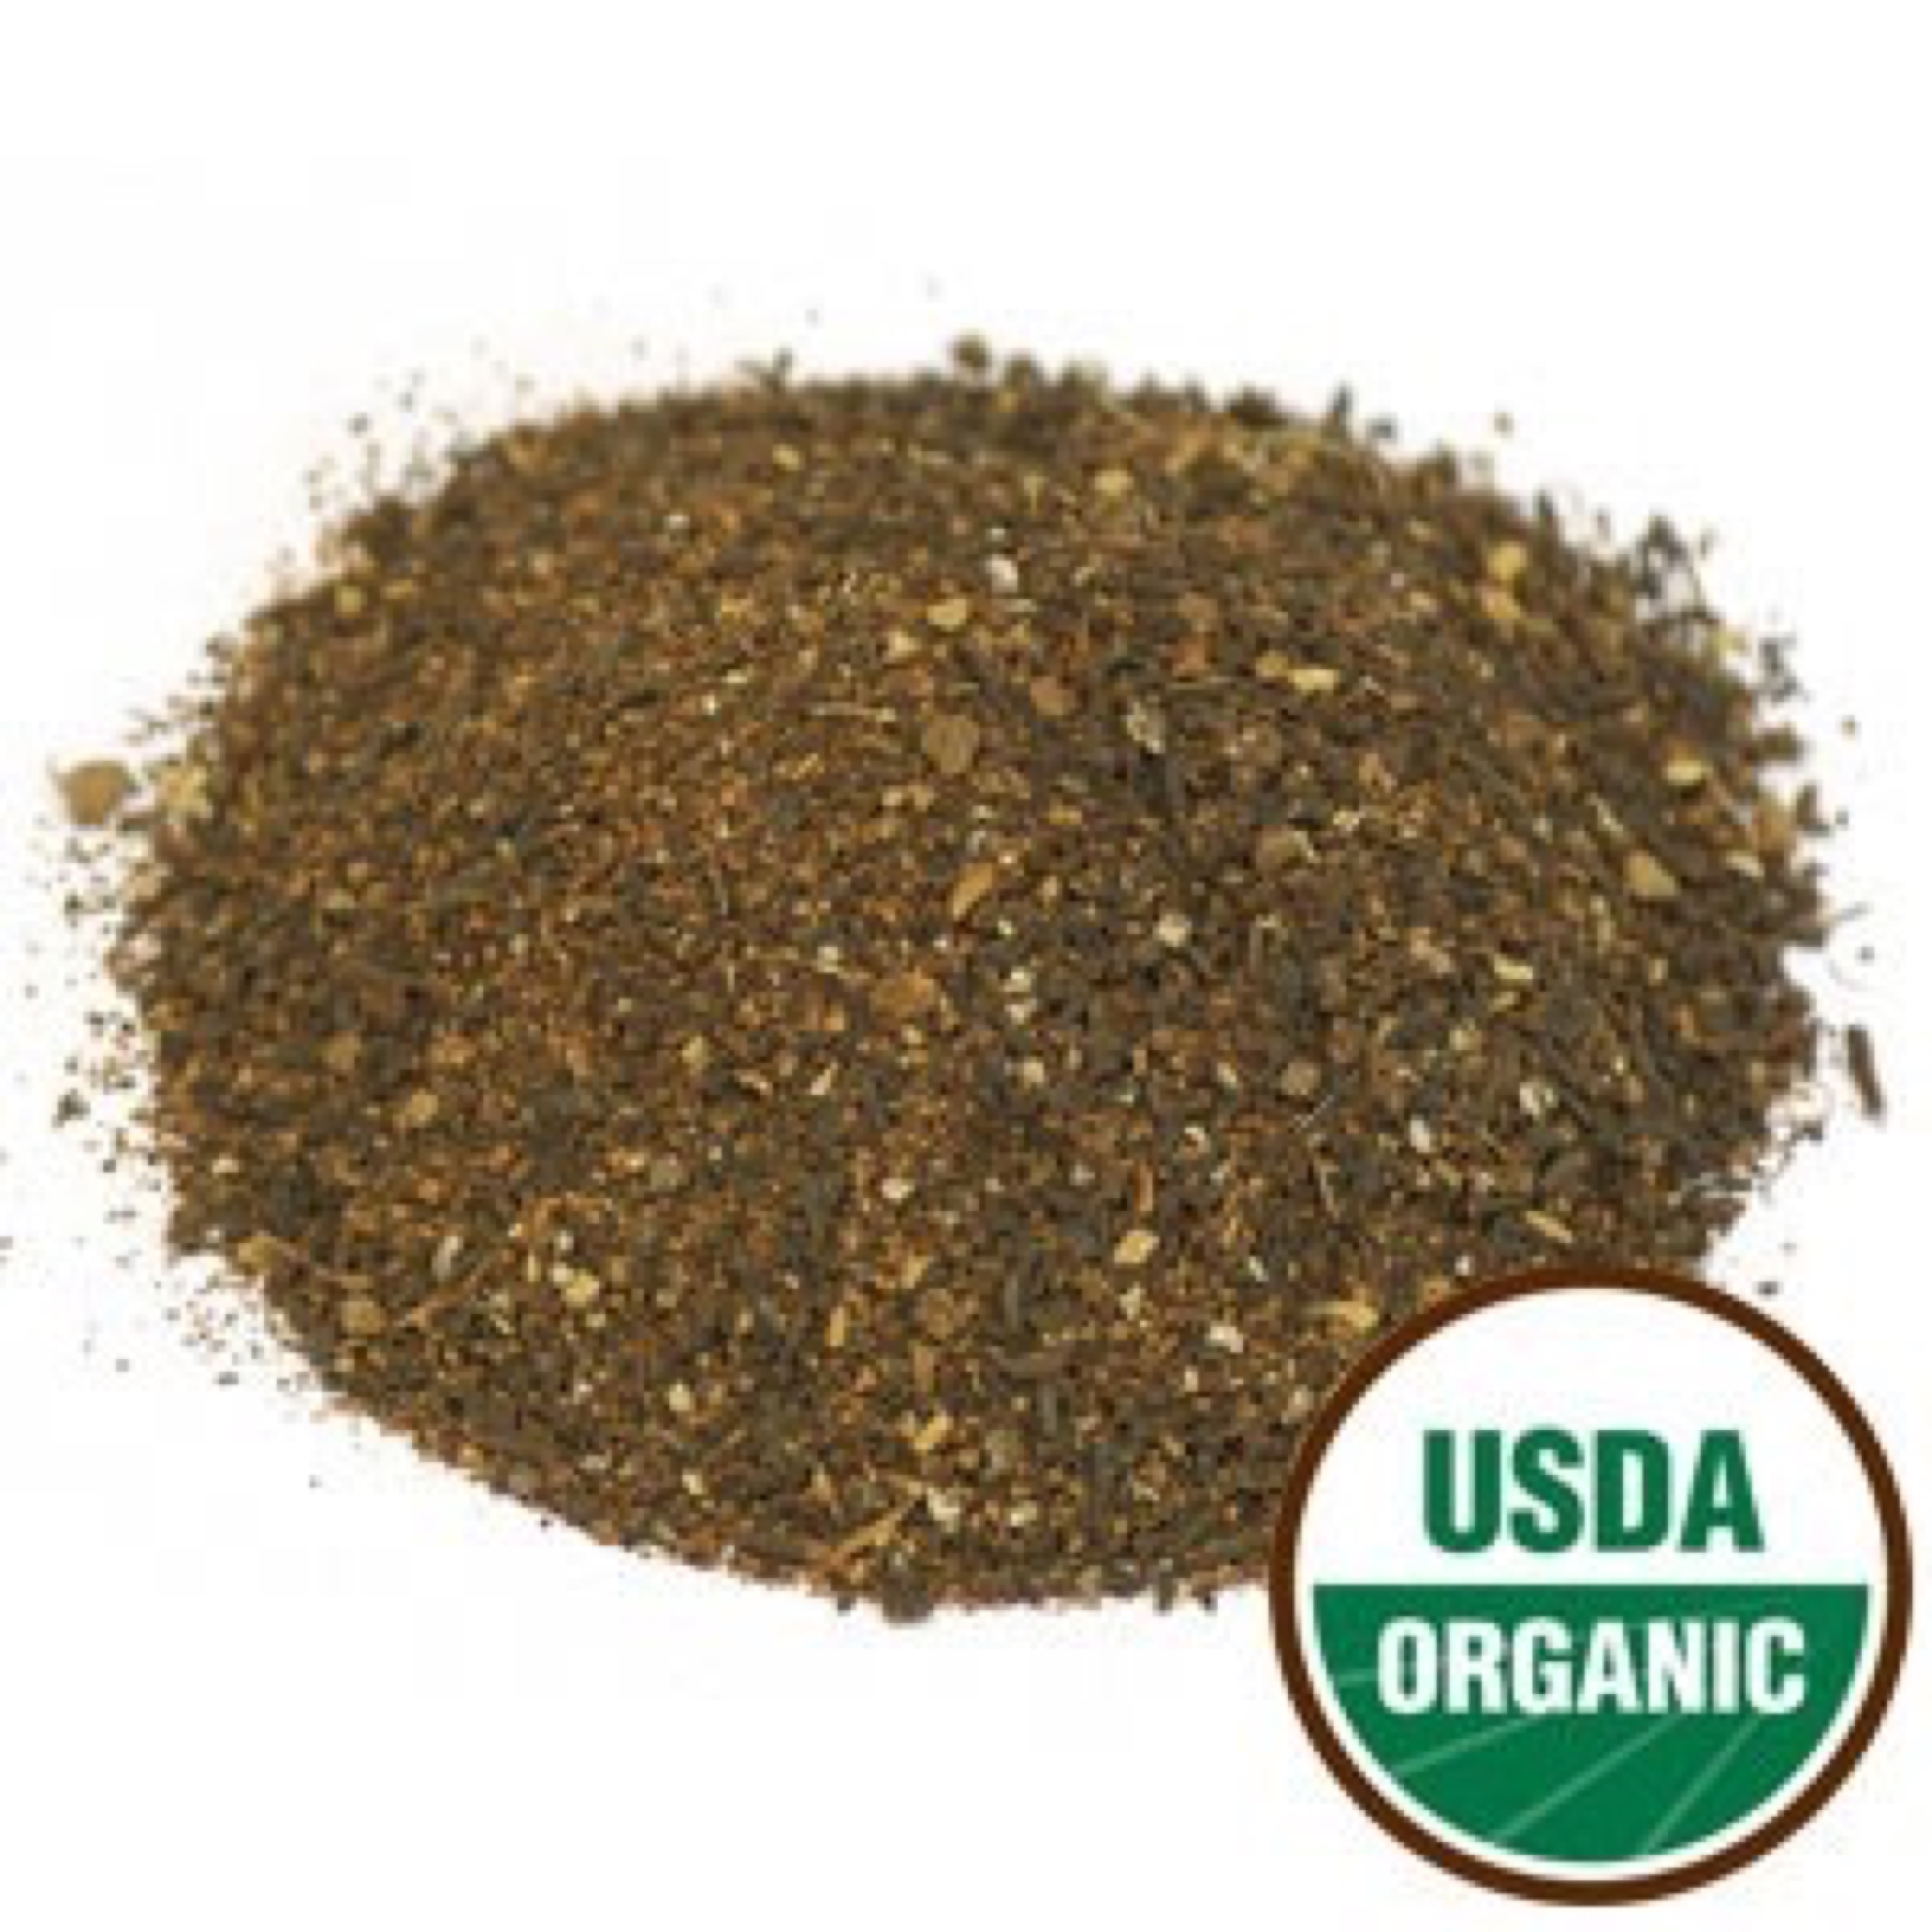

Chai

Chai Tea Organic

This traditional drink of India has a distinctively, delicious taste. It combines a mixture of organic black teas along with sweet and zesty organic spices including cinnamon, cardamom, and cloves to create a uniquely rich and spicy beverage. Chai Tea is usually sweetened, so try adding a pinch of stevia, a dash of vanilla, or even milk. It tastes great whether served hot or cold!

Ingredients: Organic China Black F.O.P. tea, organic cinnamon, organic Assam tea, organic cardamom seed, organic cloves, organic ginger root and organic black pepper.

Flowery Orange Pekoe (F.O.P.) refers to a high quality whole leaf tea with a long leaf and good balance of tips. FOP contains fine, tender young leaves with buds (referred to as tips) and is made from the first two leaves and bud of the shoot. When harvested during the slow growth periods, these young buds have a golden tip, hence the grade 'Flowery', thus making it Flowery Orange Pekoe (FOP).

Daily serving size: Pour 8 oz of boiling water (212° F) over 1 tsp. of tea. Steep 4-5 minutes. Add 2 oz of hot milk (or dairy substitute), and sweeten with honey or sugar to taste.

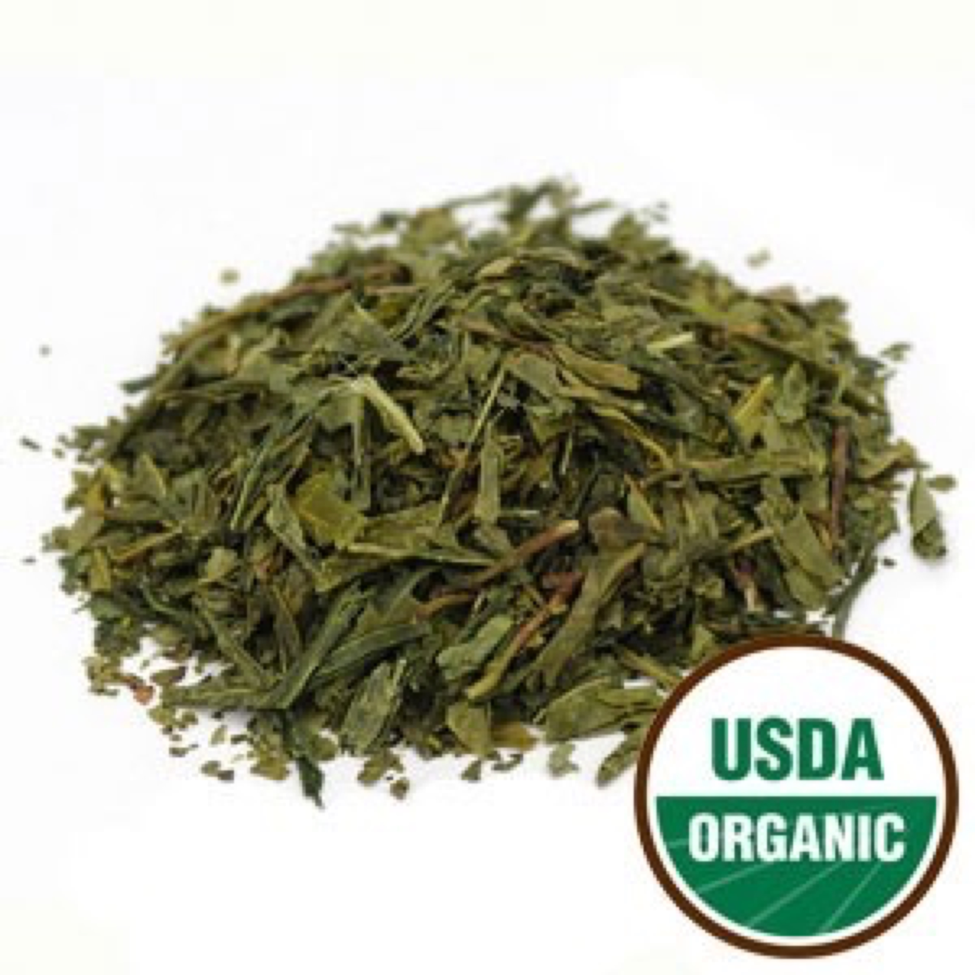

Bancha Tea Organic

**Bancha Tea Organic (China**) Green

Botanical Name: Camellia sinensis

Origin: China

Description

Bancha Tea Organic (China)

Plucked and produced according to ancient Japanese tradition, this is the tea to recommend the next time you’re asked for something easy drinking, at any time of day. In Japan, Bancha’s ancestral home, this grassy green brew has long been considered the journeyman of teas and is the cup of tea most commonly consumed. Bancha itself is notable for the fact that it is plucked from the same bushes as Sencha, arguably the best-known Japanese variety on the international stage. The difference is that the leaves used to produce Bancha are typically plucked and harvested later, after Sencha season, resulting in a coarser appearance that often includes some stalk and stem. The coarse quality of the loose leaf gives the tea a unique character, milder infusion and lowered caffeine and tannin levels compared to many finer grade green teas. Bancha Tea has a light, refreshing flavor, with a mildly vegetal finish. It’s your everyday drink: toasty, energetic, and strong.

Daily serving size: Pour 8-12 oz of simmering water (180° F preferred) over 1 tsp. of tea. Steep 2-3 minutes.

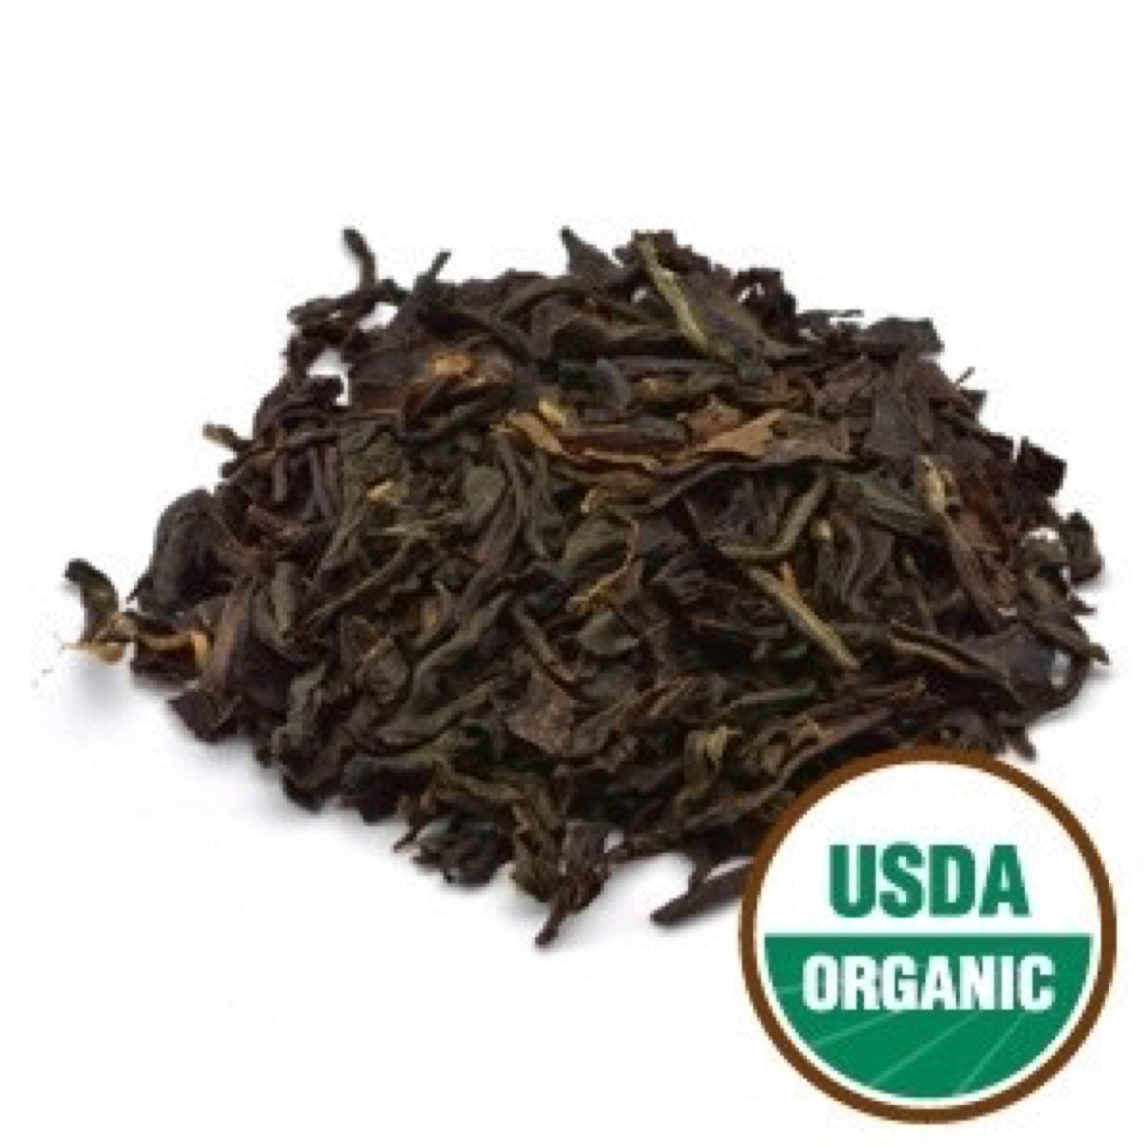

**Black Currant Flavored Tea Organic Black**

Origin: United States

Description

Black Currant Flavored Tea Organic

This tea is deliciously smooth and slightly sweet, with a fragrant floral aroma. Black currants have a slightly sweet earthy taste, unlike other berries, and when the sweet black currant flavor is combined with our premium full bodied black teas, it gives it a very distinct taste. It is great any time of the day, hot or iced, and it complements any treat.

Tippy Golden Flowery Orange Pekoe (T.G.F.O.P.) is FOP with a larger amount of tips. When these tips are in abundance, the terms 'Tippy and Golden' are attached to FOP, thus making it Tippy Golden Flowery Orange Pekoe. TGFOP is the top grade of OP tea.

Flowery Orange Pekoe (F.O.P.) refers to a high quality whole leaf tea with a long leaf and good balance of tips. FOP contains fine, tender young leaves with buds (referred to as tips) and is made from the first two leaves and bud of the shoot. When harvested during the slow growth periods, these young buds have a golden tip, hence the grade 'Flowery', thus making it Flowery Orange Pekoe (FOP).

Ingredients: Organic China Black F.O.P. Tea, Organic Assam T.G.F.O.P. Tea, and organic flavor.

Daily serving size: Pour 8 oz of simmering water (185-195° F preferred) over 1 tsp. of tea. Steep 3-4 minutes.

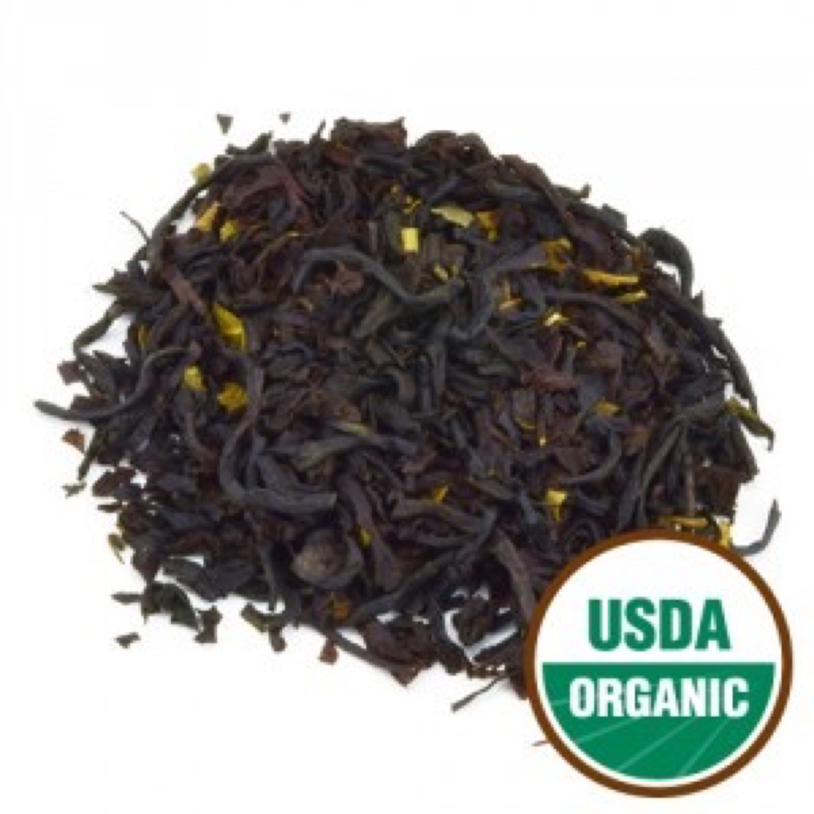

**Blackberry Flavored Tea Organic Herbal**

This Blackberry Flavored Tea is a blend of our premium full bodied black teas flavored with blackberry, making it a lush, fruity, sweet steep with floral notes. It is a wonderfully smooth treat that is delicious both hot and cold. Try it with a bit of sugar or over ice with a sprig of mint for a refreshing taste- It makes a tasty iced tea!

Tippy Golden Flowery Orange Pekoe (T.G.F.O.P.) is FOP with a larger amount of tips. When these tips are in abundance, the terms 'Tippy and Golden' are attached to FOP, thus making it Tippy Golden Flowery Orange Pekoe. TGFOP is the top grade of OP tea.

Flowery Orange Pekoe (F.O.P.) refers to a high quality whole leaf tea with a long leaf and good balance of tips. FOP contains fine, tender young leaves with buds (referred to as tips) and is made from the first two leaves and bud of the shoot. When harvested during the slow growth periods, these young buds have a golden tip, hence the grade 'Flowery', thus making it Flowery Orange Pekoe (FOP).

Ingredients: Organic China Black F.O.P. Tea, Organic Assam T.G.F.O.P. Tea, organic blackberry leaf, and organic flavor.

Daily serving size: Pour 8 oz of simmering water (185-195° F preferred) over 1 tsp. of tea. Steep 3-4 minutes.

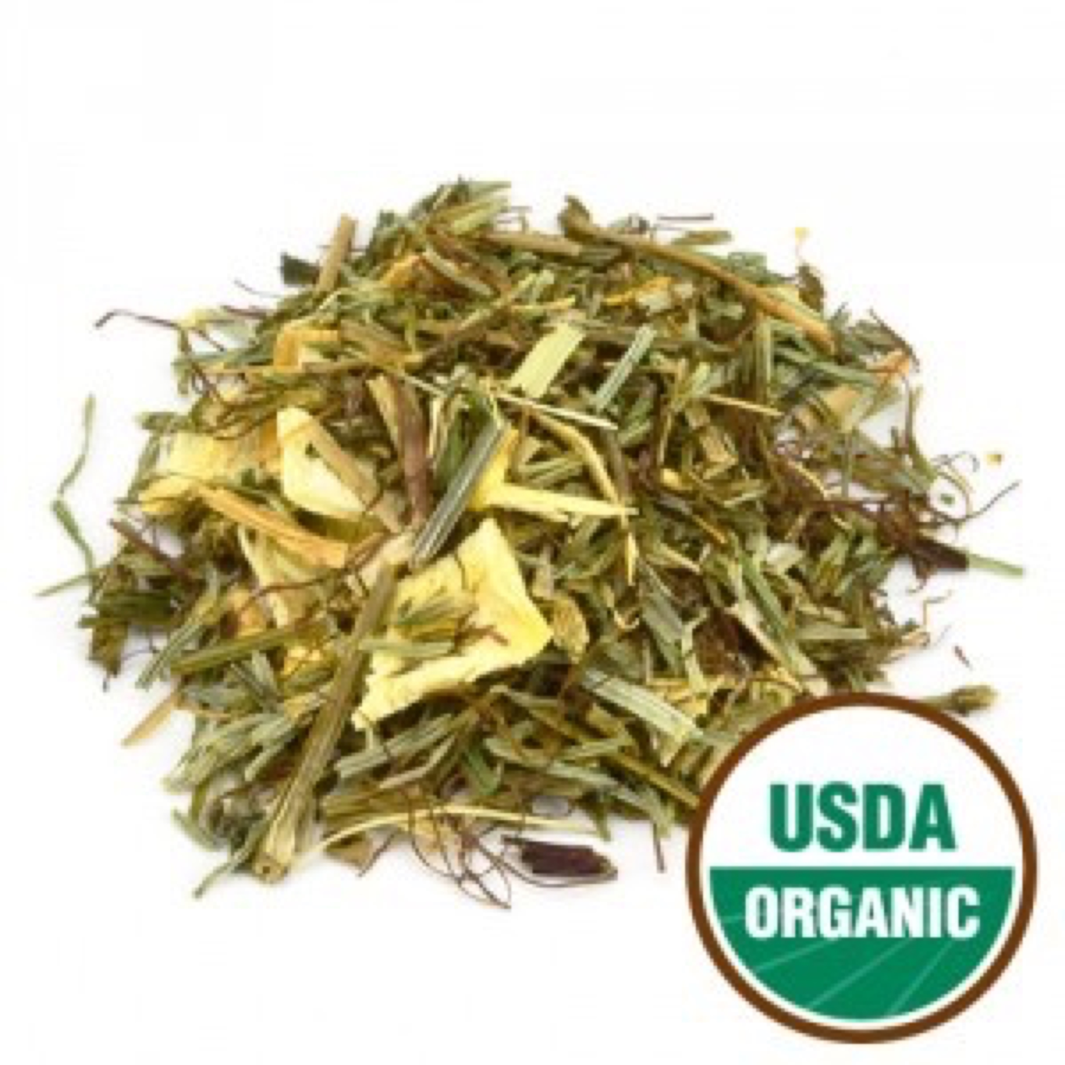

**Bladder Support Tea Organic Herbal**

This formula is a masterful mix of herbs designed to support and maintain healthy bladder function. Caffeine-Free.

Ingredients: Organic cleavers herb, organic shavegrass herb, organic couchgrass root, organic cornsilk, and organic juniper berry.

Daily serving size: Pour 8-12 oz of boiling water (212° F) over 1 tsp. of tea. Steep 3-4 minutes.

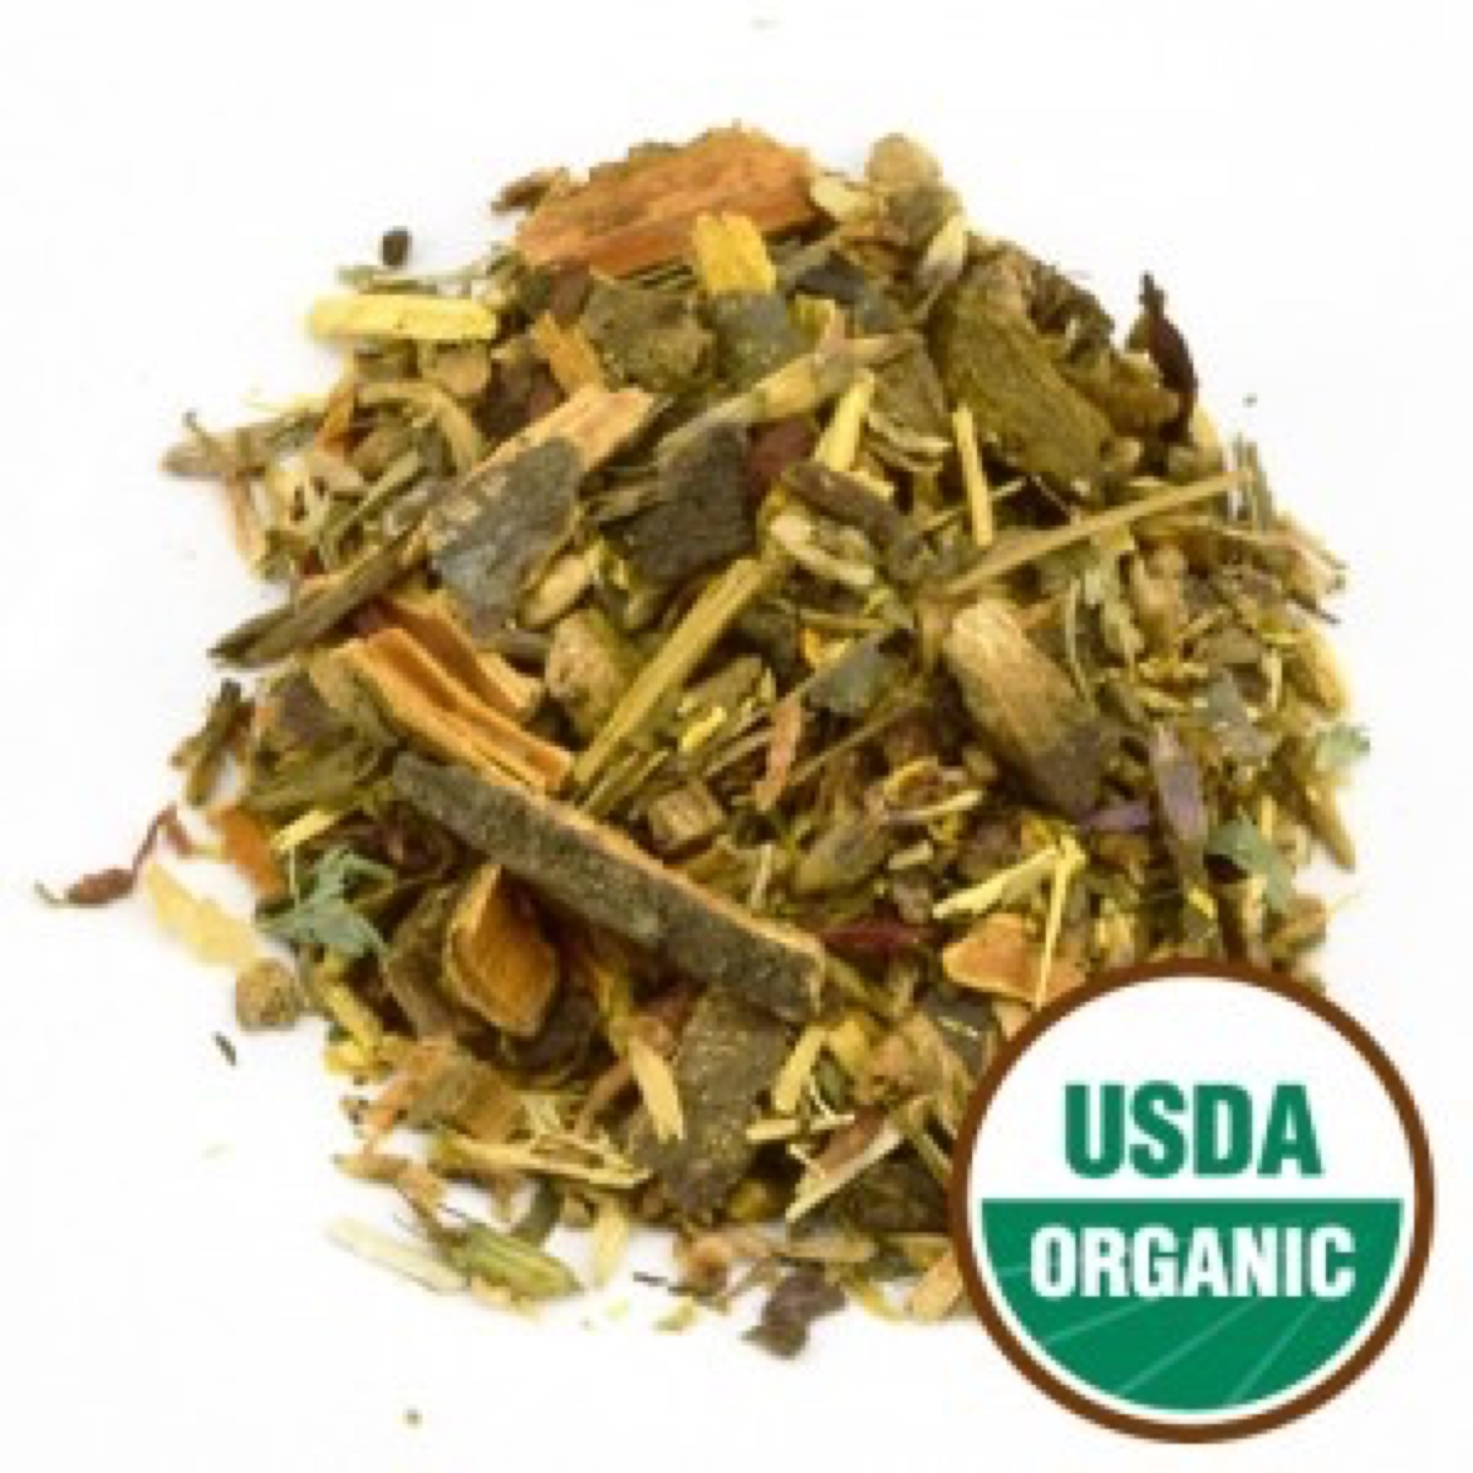

Blood Cleanser Tea Organic **Herbal**

Our Blood Cleanser formula is a specific combination of herbs to help aid in the health and purification of the blood. Caffeine-Free.

Ingredients: Organic buckthorn bark, organic burdock root, organic red clover blossoms, organic yellowdock root, organic barberry root,and organic licorice root.

Warning: NOTICE: This product contains Buckthorn Bark (Rhamnus frangula). Read and follow directions carefully. Do not use if you have or develop diarrhea, loose stools, or abdominal pain because Buckthorn Bark may worsen these conditions and be harmful to your health. Consult your physician if you have frequent diarrhea or if you are pregnant, nursing, taking medication, or have a medical condition.

Daily serving size: Pour 8-12 oz of boiling water (212° F) over 1 tsp. of tea. Steep 3-4 minutes.

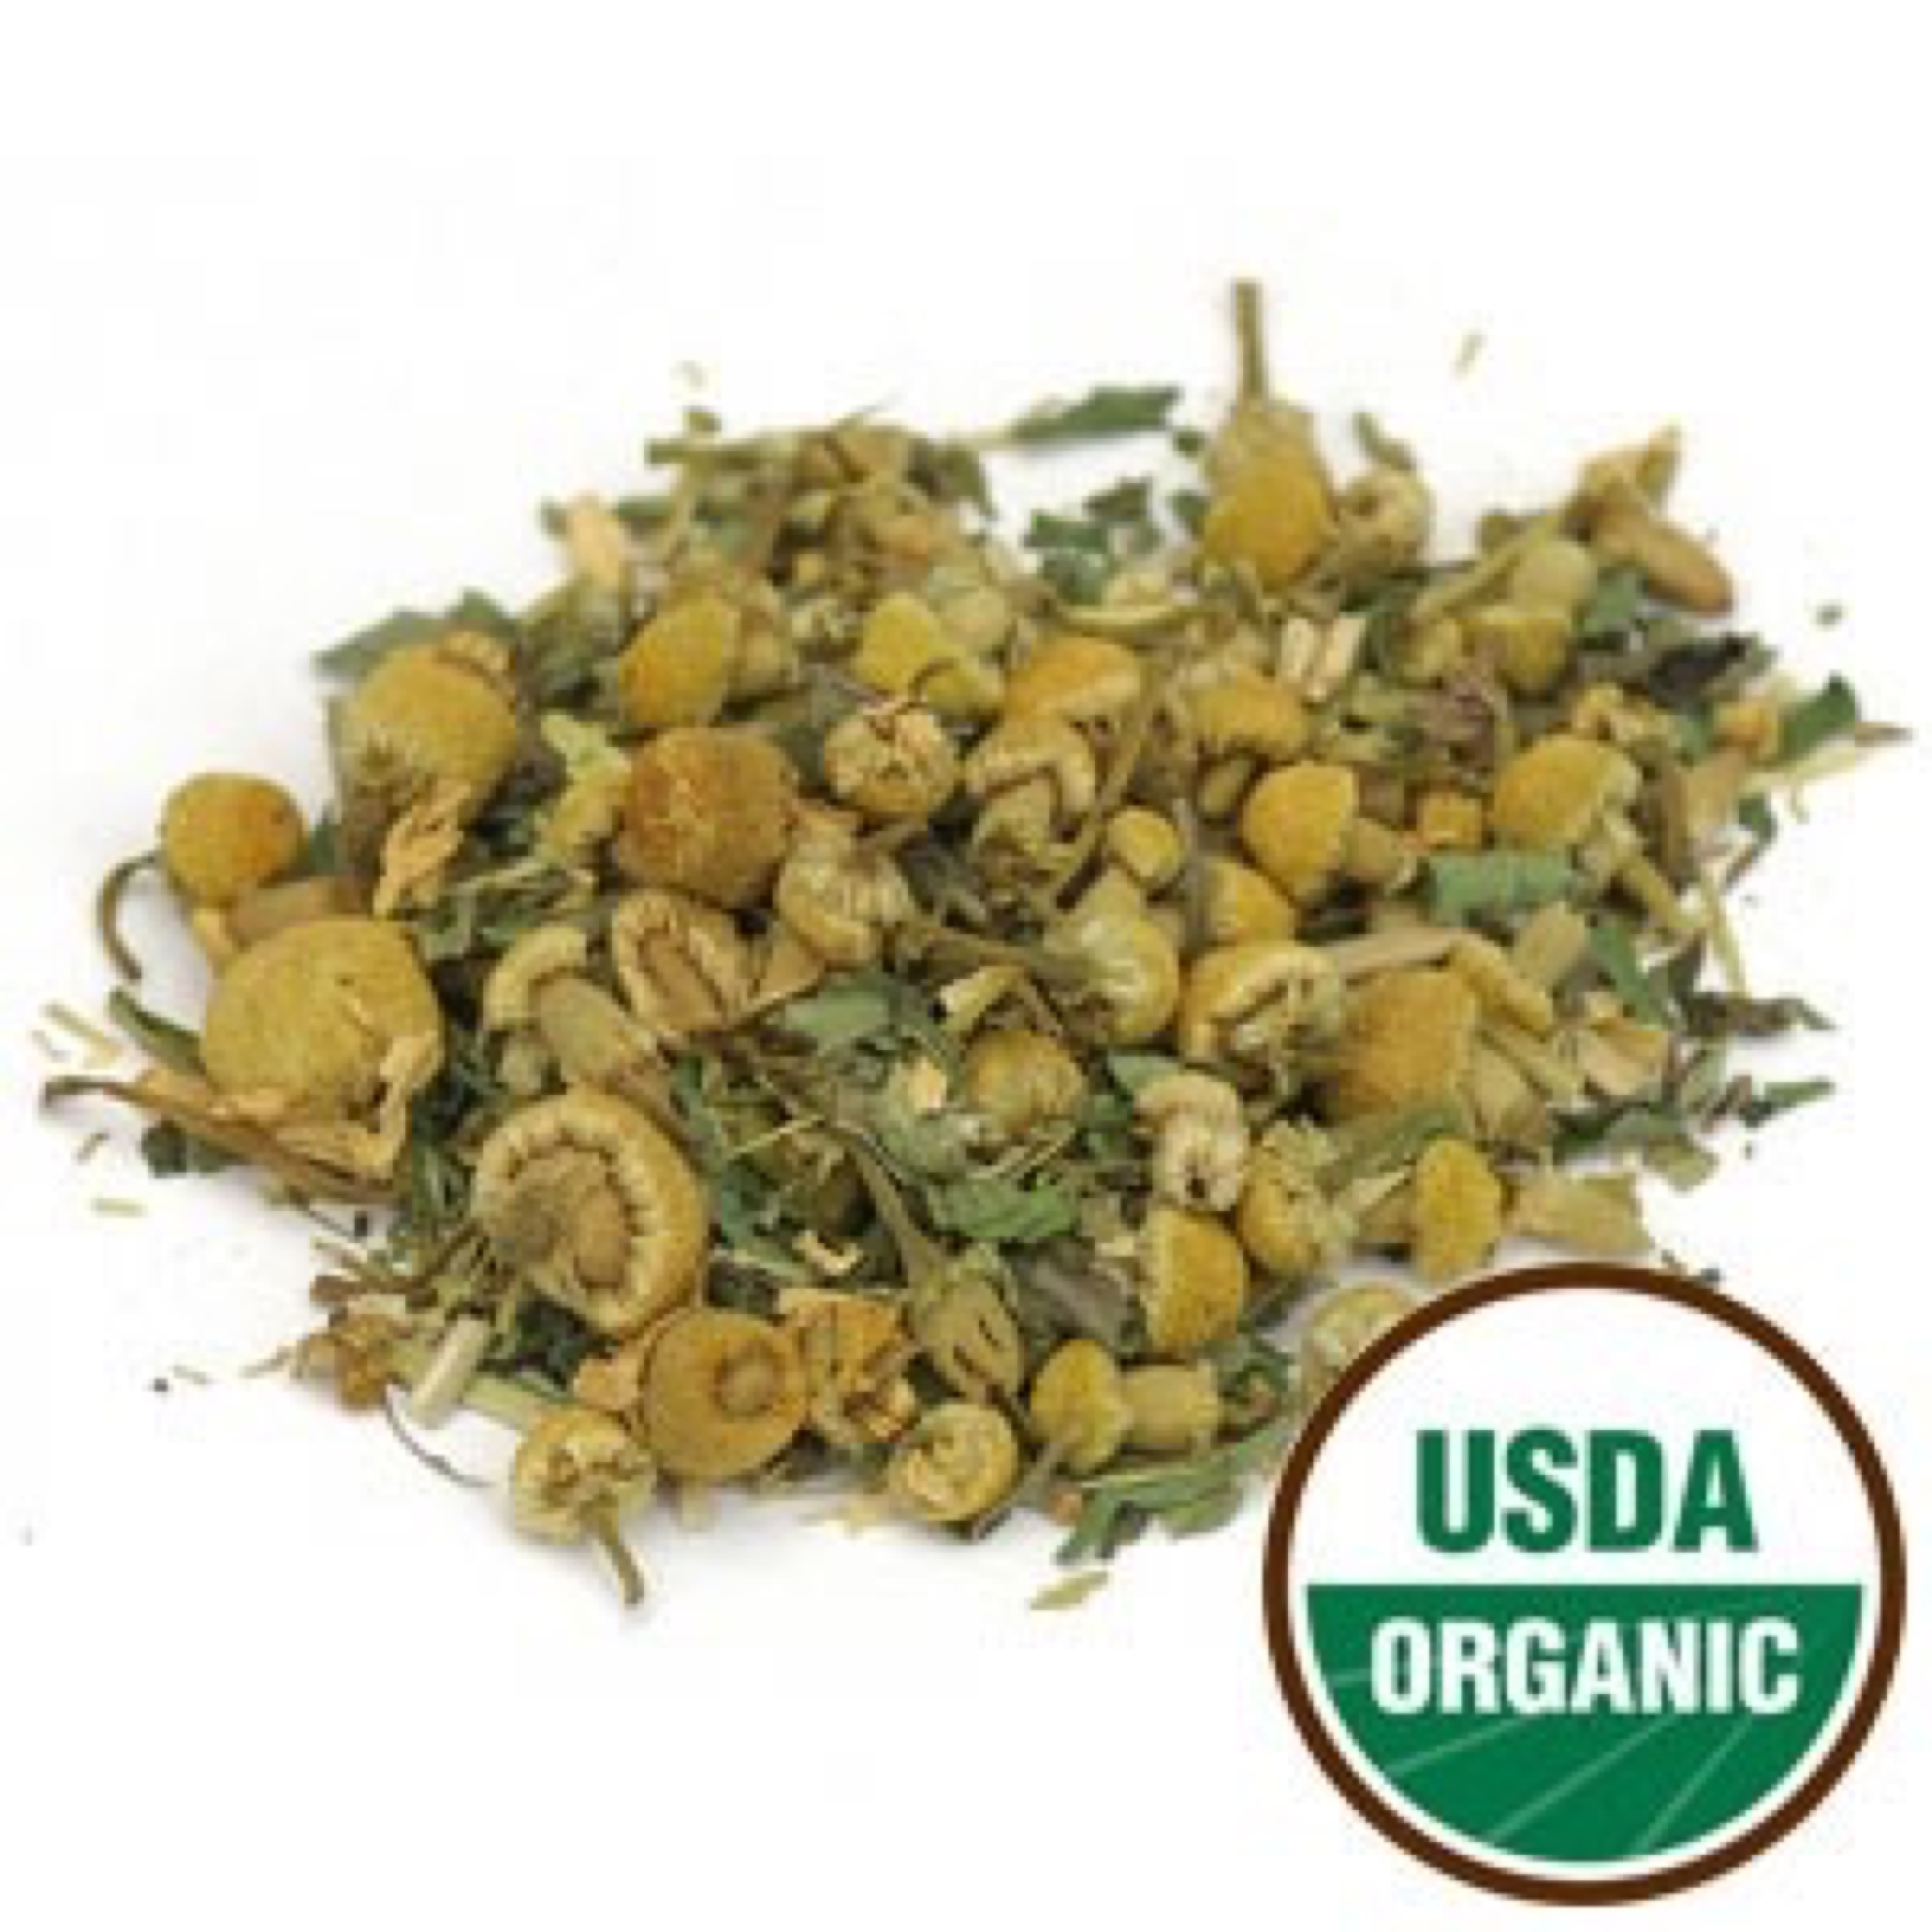

Calming Rest Tea Organic **Herbal**

An Indian decaffeinated green tea infusion with chamomile and other delicious herbs, combined with the refreshing taste of peppermint. This soothing blend gives you a full-bodied flavor, promoting calm relaxation, and helps you to unwind and ease your mind to melt the stress of your day away so you can get a good nights rest. Caffeine-Free.

Ingredients: Organic chamomile, organic peppermint, organic Indian green tea decaffeinated, organic scullcap herb, organic wood betony, organic catnip herb and organic stevia leaf.

Daily serving size: Pour 8-12 oz of boiling water (212° F) over 1 tsp. of tea. Steep 3-4 minutes.

Packaging: To preserve freshness, aroma, and potency, our 1 lb loose teas are packaged in a polyfoil bag with a re-sealable zipper closure, protecting the contents from light exposure and moisture.

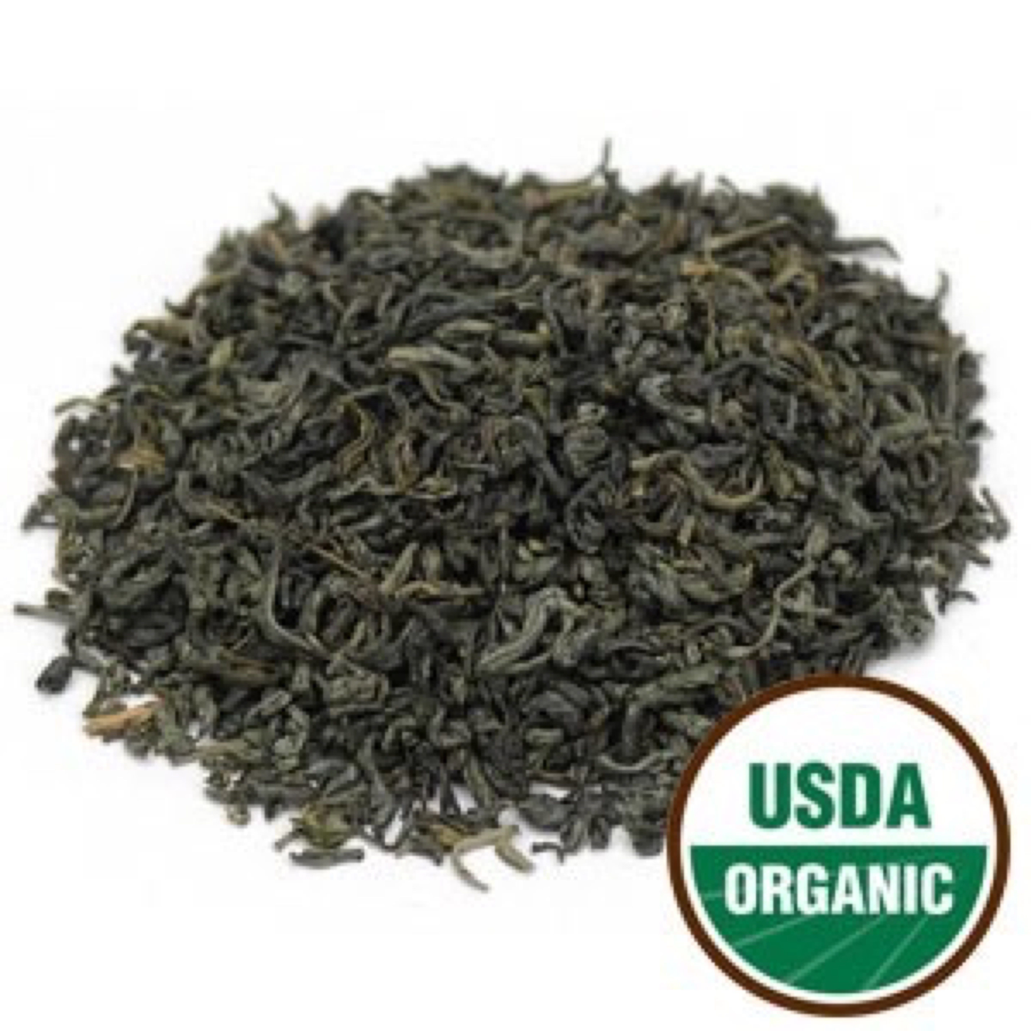

Chunmee Green Tea Organic Green

Chunmee (eyebrow tea) gets its name from the curve of the processed leaf. The leaves are carefully hand rolled to the shape of eye-brows and then pan-fried. The pan-fried leaves produce a highly fragrant, yellow-greenish brew with a distinctive, sweet flavor, and is known for its plum-like sweetness and smoothness.

Daily serving size: Pour 8-12 oz of simmering water (180° F preferred) over 1 tsp. of tea. Steep 2-3 minutes.

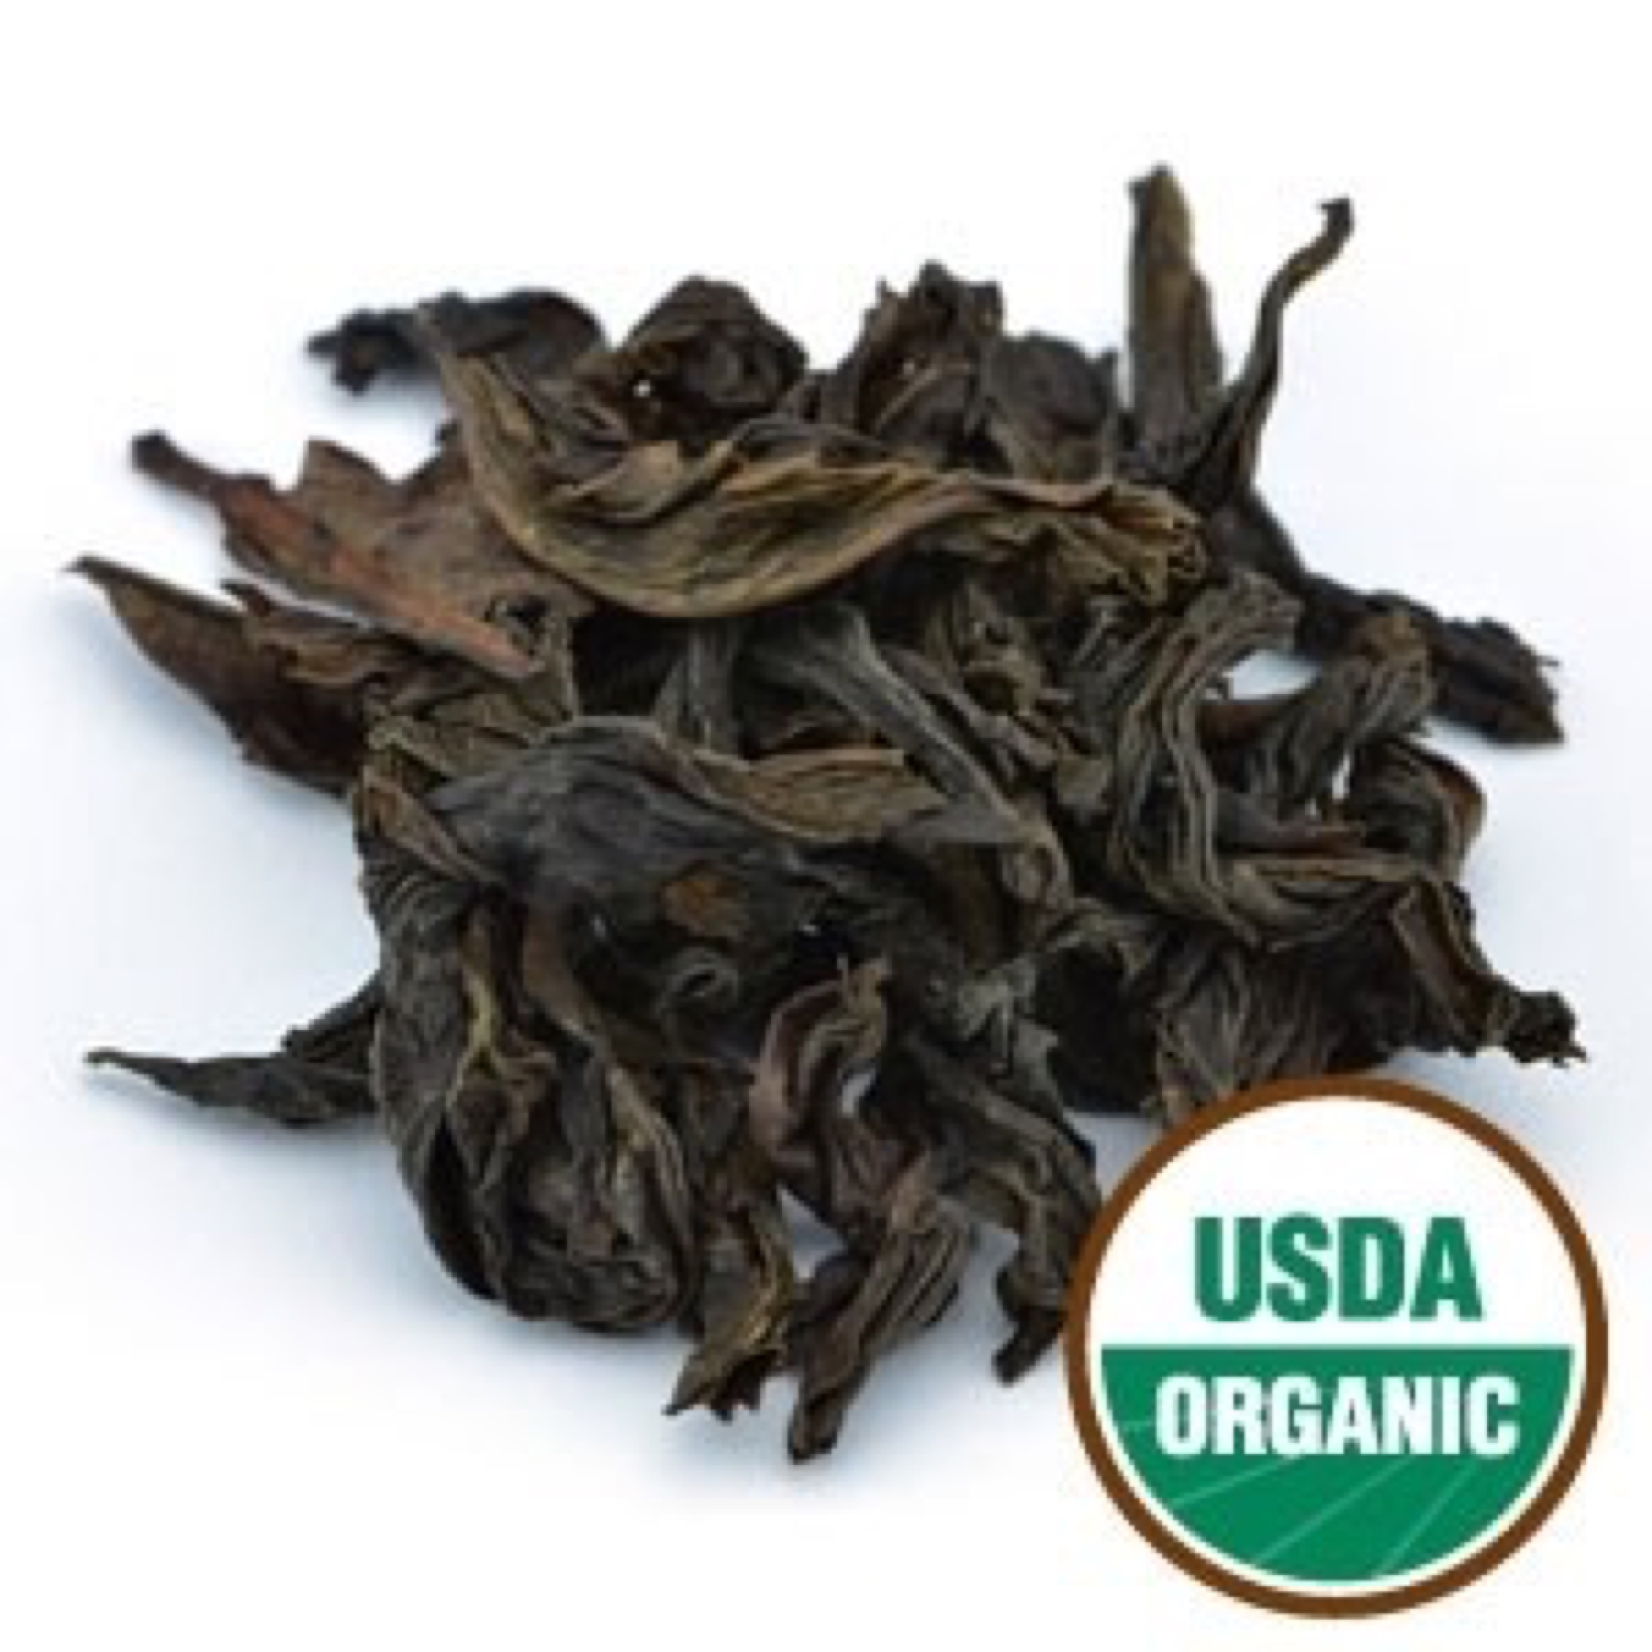

Da Hong Pao Oolong O.P. Tea Organic oolong

Da Hong Pao is one of the most famous oolong teas in the world. It comes from the famous Wuyi Mountains in the Fujian Province of China. It is one of 5 ‘Rock Teas’, meaning the teas are grown in more rocky areas making the mineral content in the soil much denser. This is what gives the 5 rock teas their signature flavors. This very full bodied tea has a roasted flavor with a very particular sweetness to it and is reminiscent of baked goods or molasses.

Orange Pekoe (O.P.) is a high quality grade whole leaf tea that does not usually contain tips and consists of many whole, thin and wiry tea leaves of a uniform size. Usually harvested when the end buds open into a leaf, and picked later than F.O.P.).

Daily serving size: Pour 8-12 oz of simmering water (180° F) over 1 tsp. of tea. Steep 2-3 minutes.

Packaging: To preserve freshness, aroma, and potency, our 1 lb loose teas are packaged in a polyfoil bag with a re-sealable zipper closure, protecting the contents from light exposure and moisture.

California Proposition 65 WARNING: Consuming this product can expose you to lead, which is known to the State of California to cause birth defects or other reproductive harm. For more information go to www.P65Warnings.ca.gov/food.

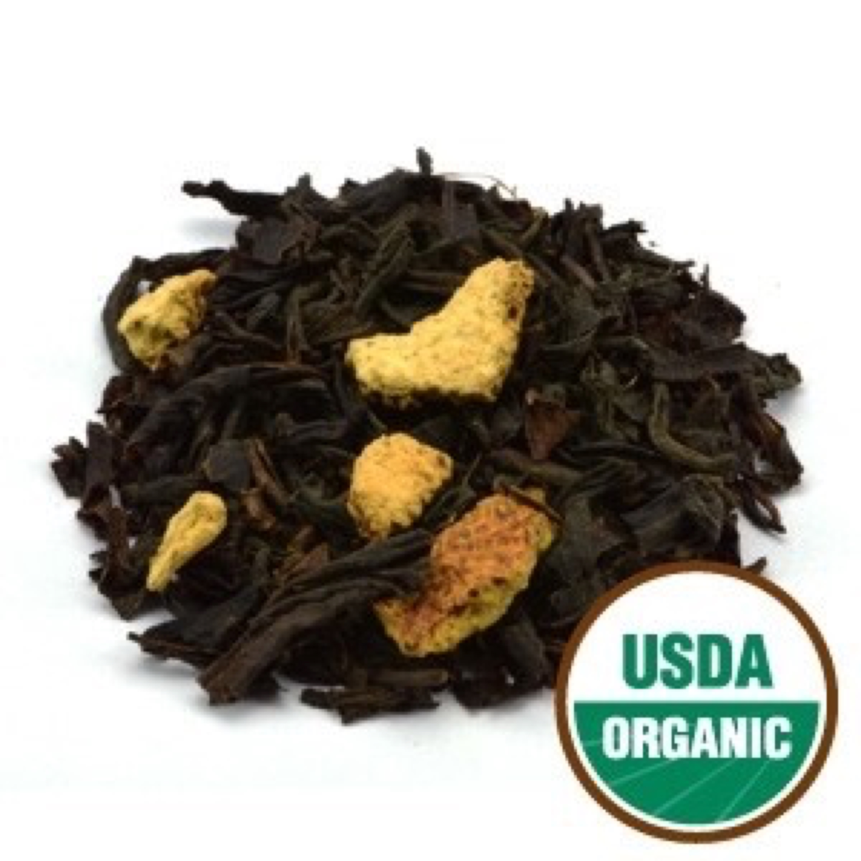

Cinnamon Orange Spice Tea Organic Black

This blend unites our full bodied black teas with the flavor or cinnamon and the natural citrus flavor of orange giving it a fragrant spicy and fruity flavor. This warming, revitalizing tea has a spicy cinnamon flavor with a touch of sweet citrusy orange, making it a robustly flavorful, warming tea.

Flowery Orange Pekoe (F.O.P.) refers to a high quality whole leaf tea with a long leaf and good balance of tips. FOP contains fine, tender young leaves with buds (referred to as tips) and is made from the first two leaves and bud of the shoot. When harvested during the slow growth periods, these young buds have a golden tip, hence the grade 'Flowery', thus making it Flowery Orange Pekoe (FOP).

Ingredients: Organic China Black F.O.P. Tea, organic orange peel, organic cassia oil, and organic orange oil.

Daily serving size: Pour 8-12 oz of simmering water (212° F) over 1 tsp. of tea. Steep 3-4 minutes.

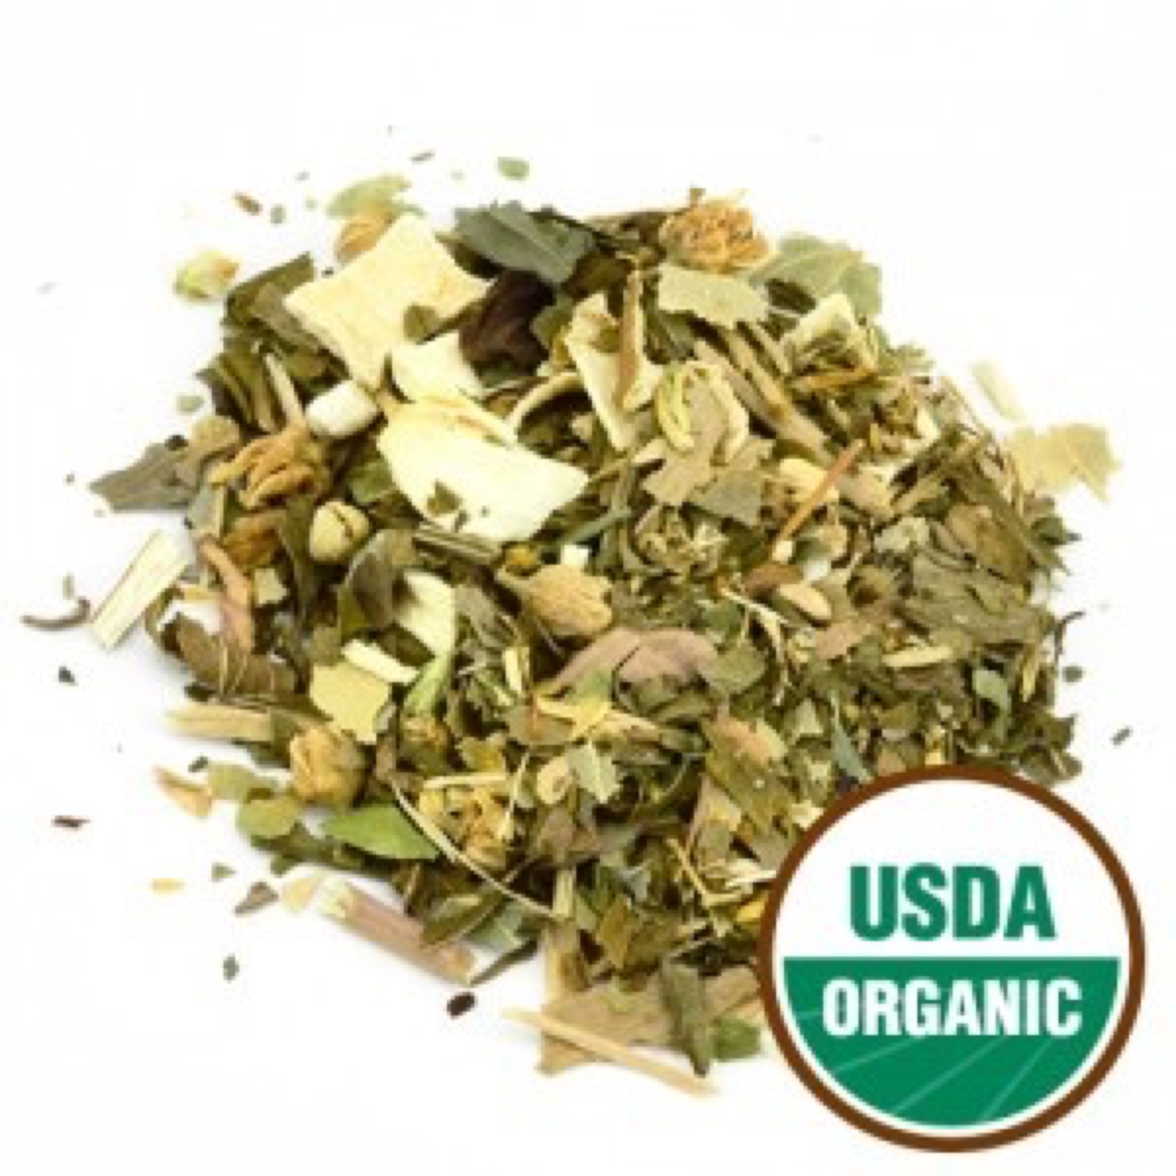

Circulation Tea Organic Herbal

Our circulation formula is made with a blend of organic herbs designed to help promote and support a healthy circulatory system. Caffeine-Free.

Ingredients: Organic goldenrod herb, organic linden flower and leaf, organic eleuthero root, organic ginkgo leaf, organic peppermint leaf, organic cinnamon, and organic gentian root.

Daily serving size: Pour 8-12 oz of boiling water (212° F) over 1 tsp. of tea. Steep 3-4 minutes.

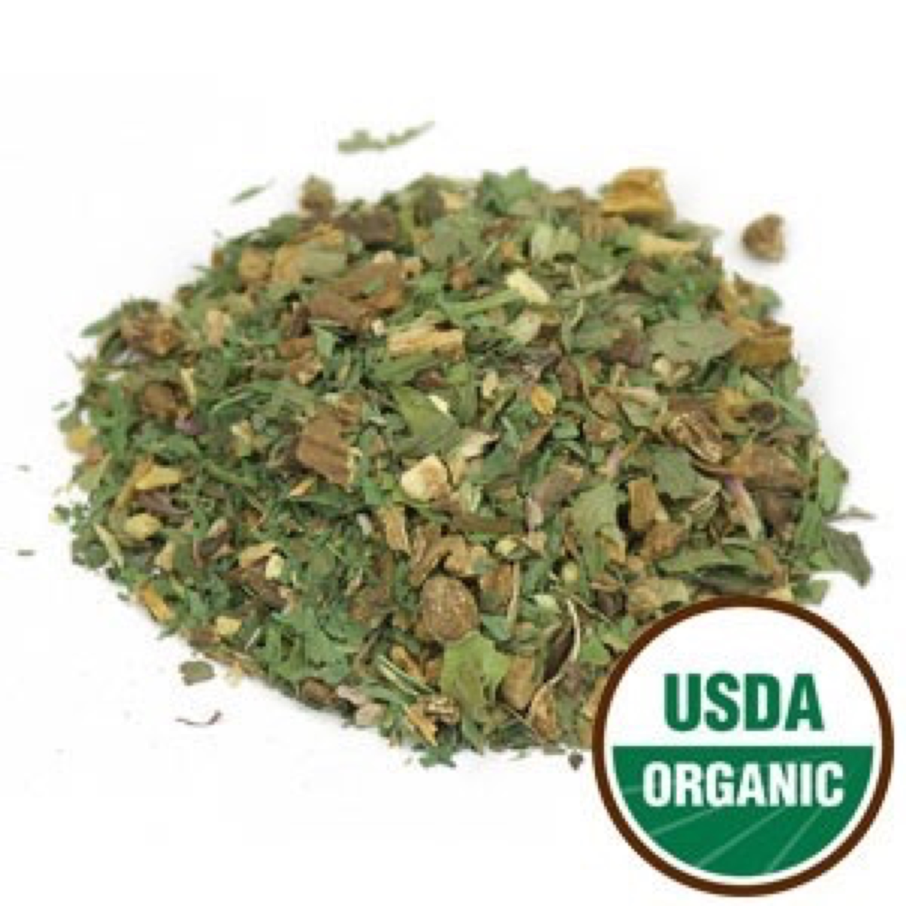

Detox Tea Organic Herbal

Enjoy this blend of healthful herbs, including dandelion, red clover, and licorice, that can help provide a gentle way for the body to cleanse itself. A delicious way to feel naturally refreshed on a daily basis. Caffeine-Free.

Ingredients: Organic burdock root, organic dandelion root, organic peppermint leaf, organic red clover blossom, organic licorice root, organic yellowdock root, and organic ginger root.

Daily serving size: Pour 8-12 oz of boiling water (212° F) over 1 tsp. of tea. Steep 3-4 minutes.

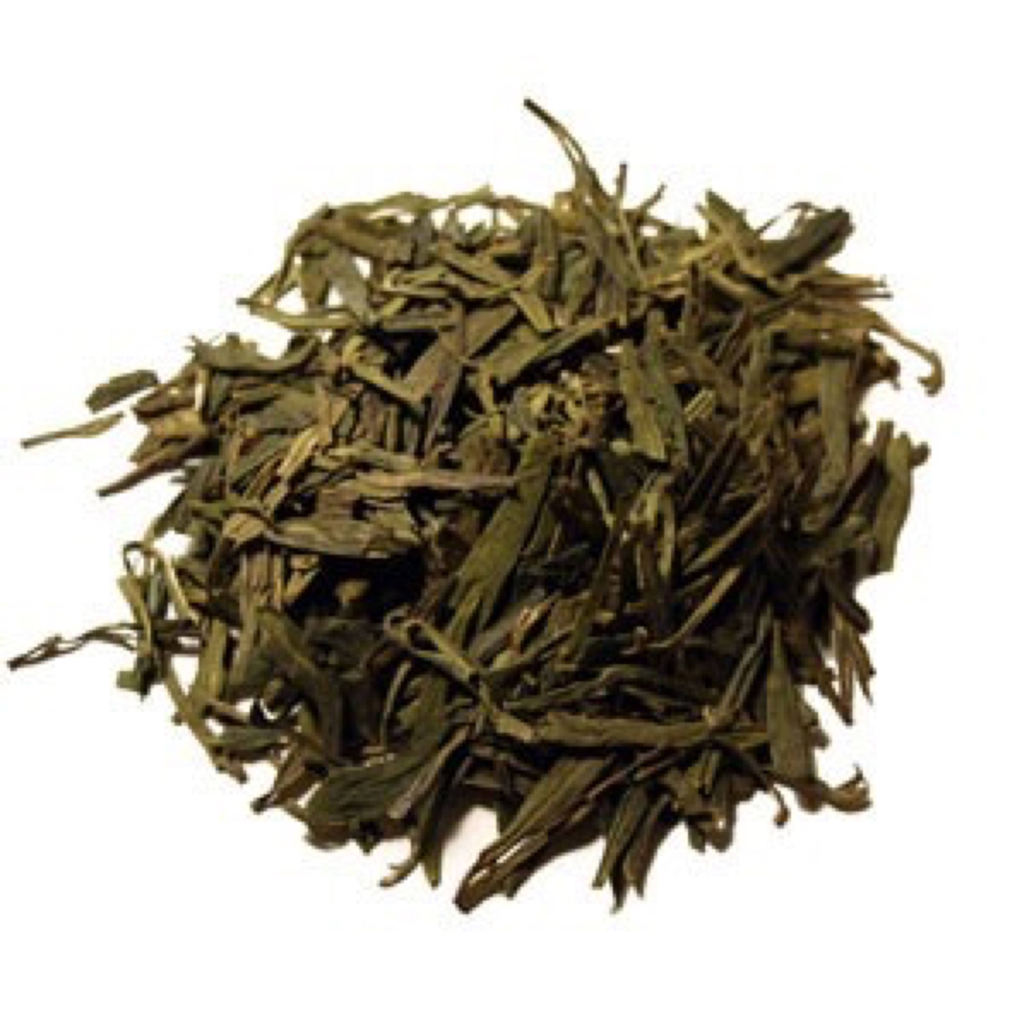

Dragonwell Tea Organic Green

This tea has a very distinctive shape: smooth and perfectly flattened along the inside vein of the leaf, the result of highly skilled shaping in a hot wok. This process, known as pan-firing or pan-frying, was perfected in China by tea masters over the centuries and gives the tea an inviting, toasty aroma. Its sweet, rounded flavor with nuances of roasted chestnut makes this a truly satisfying cup of tea. It’s especially refreshing when sipped throughout the day.

Daily serving size: Pour 8 oz of simmering water (185-195° F preferred) over 1 tsp. of tea. Steep 3-4 minutes.

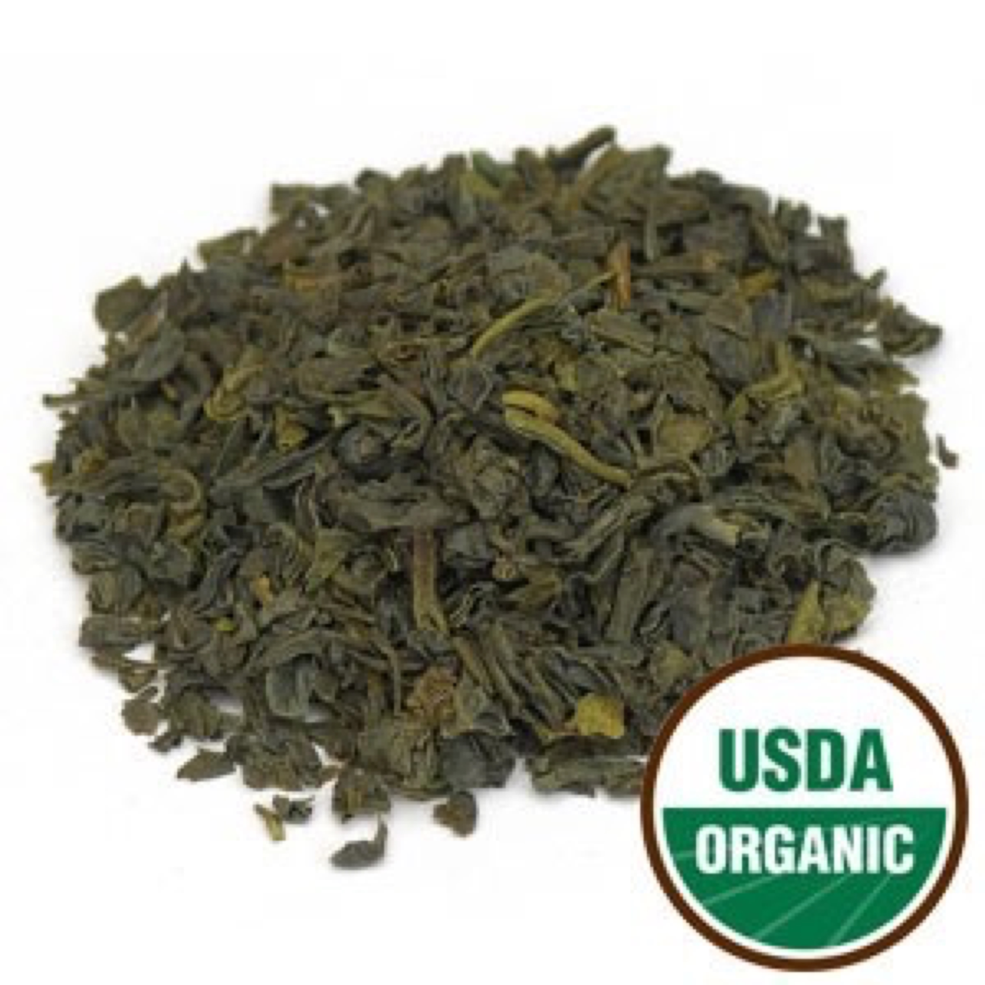

Earl Grey Green Tea Organic, Fair Trade Green

An exceptionally rich Organic Green Tea that combines full-flavored tea with citrusy bergamot oil, creating a light, smooth, and refreshing taste. This tea is an organic green tea adaptation of the classic English favorite. The vivid yellow infusion of this variety differs from Earl Grey Black Tea by delivering the characteristic Earl Grey flavor with lighter, smoother body and less astringency. It can be served hot with or without milk, sugar, or honey.

Ingredients: Organic Sencha Leaf Tea* with organic bergamot oil. *Fair Trade Certified™ by Fair Trade USA. 99% Fair Trade Certified Tea.

Daily serving size: Pour 8 oz of simmering water (185-195° F preferred) over 1 tsp. of tea. Steep 3-4 minutes.

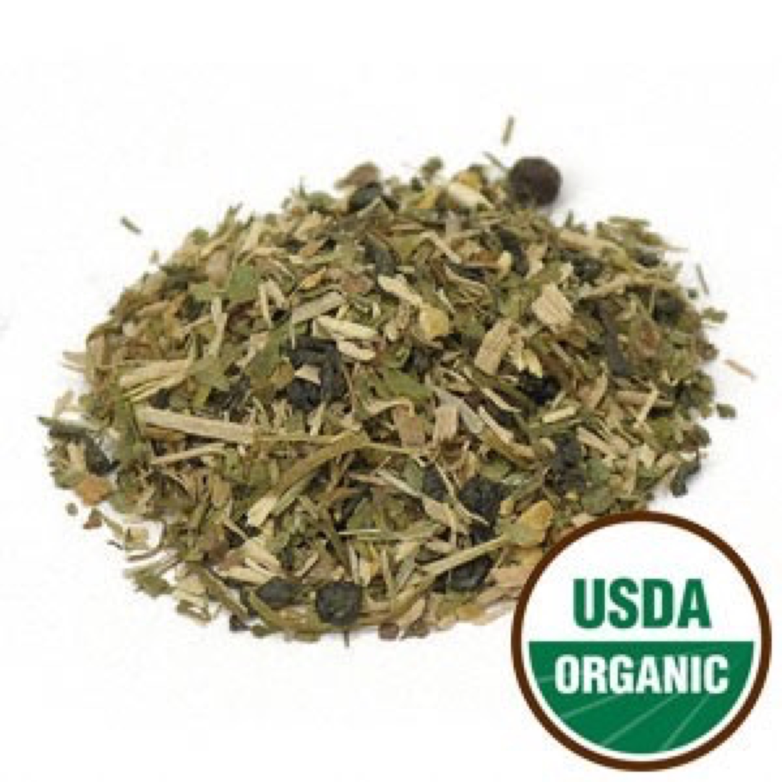

Energy Adjustment Tea Organic Herbal

Liven up your day with this blend of Organic Young Hyson green tea combined with eleuthero and ginkgo. It supplies your body with necessary antioxidants, while promoting a positive and greater energy. Enjoy this delightful, invigorating green tea throughout the day to support your energy and well-being. Revitalize yourself naturally!

Ingredients: Organic Young Hyson tea, organic eleuthero root, organic schisandra berry, organic ginkgo leaf, organic gotu kola, organic licorice root and organic ginger root.

Daily serving size: Pour 8-12 oz of boiling water (212° F) over 1 tsp. of tea. Steep 3-4 minutes.

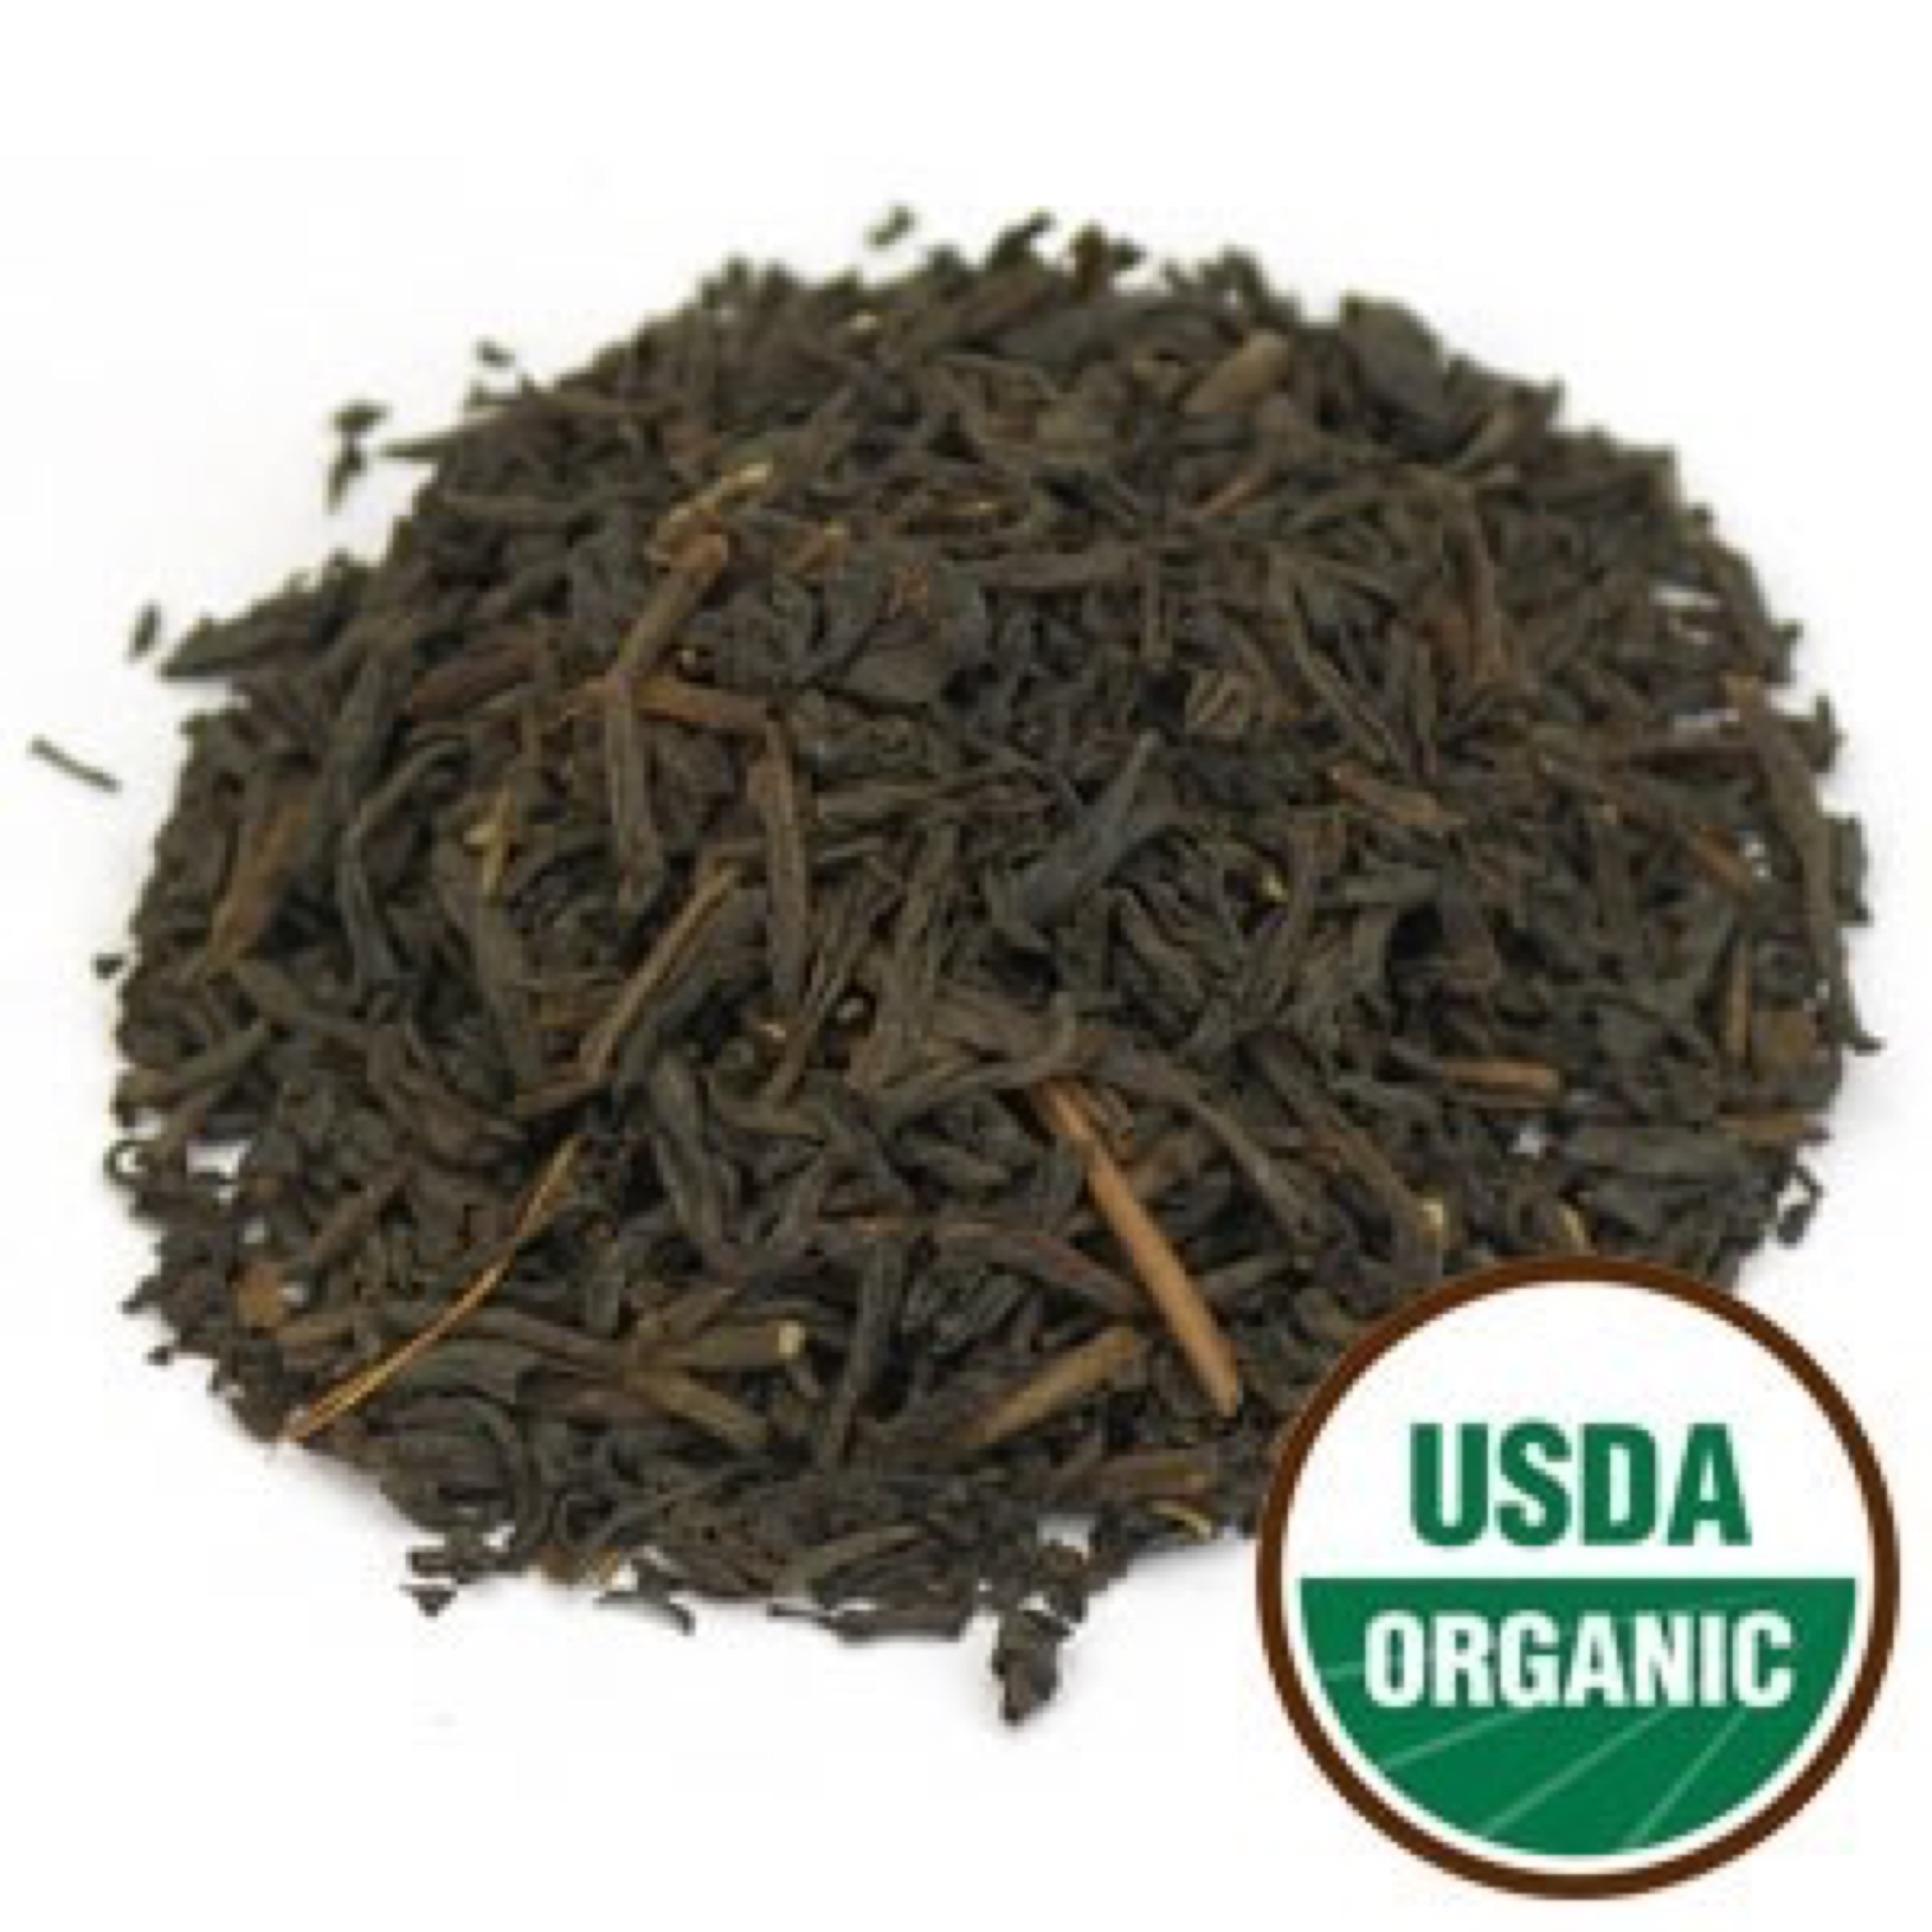

English Breakfast Tea Organic Black

This blend of black teas is usually described as a medium-bodied, rich morning beverage. It is blended to go well with milk, sugar or honey, and typically associated with a hearty breakfast. Enjoy this tea as a wonderful morning beverage or at tea-time in the afternoon with freshly baked scones or other baked goods.

Ingredients: Organic China Black F.O.P. Tea and Organic Assam T.G.F.O.P. Tea.

Flowery Orange Pekoe (F.O.P.) refers to a high quality whole leaf tea with a long leaf and good balance of tips. FOP contains fine, tender young leaves with buds (referred to as tips) and is made from the first two leaves and bud of the shoot. When harvested during the slow growth periods, these young buds have a golden tip, hence the grade 'Flowery', thus making it Flowery Orange Pekoe (FOP).

Tippy Golden Flowery Orange Pekoe (T.G.F.O.P.) is FOP with a larger amount of tips. When these tips are in abundance, the terms 'Tippy and Golden' are attached to FOP, thus making it Tippy Golden Flowery Orange Pekoe. TGFOP is the top grade of OP tea.

Daily serving size: Pour 8 oz of simmering water (185-195° F preferred) over 1 tsp. of tea. Steep 3-4 minutes.

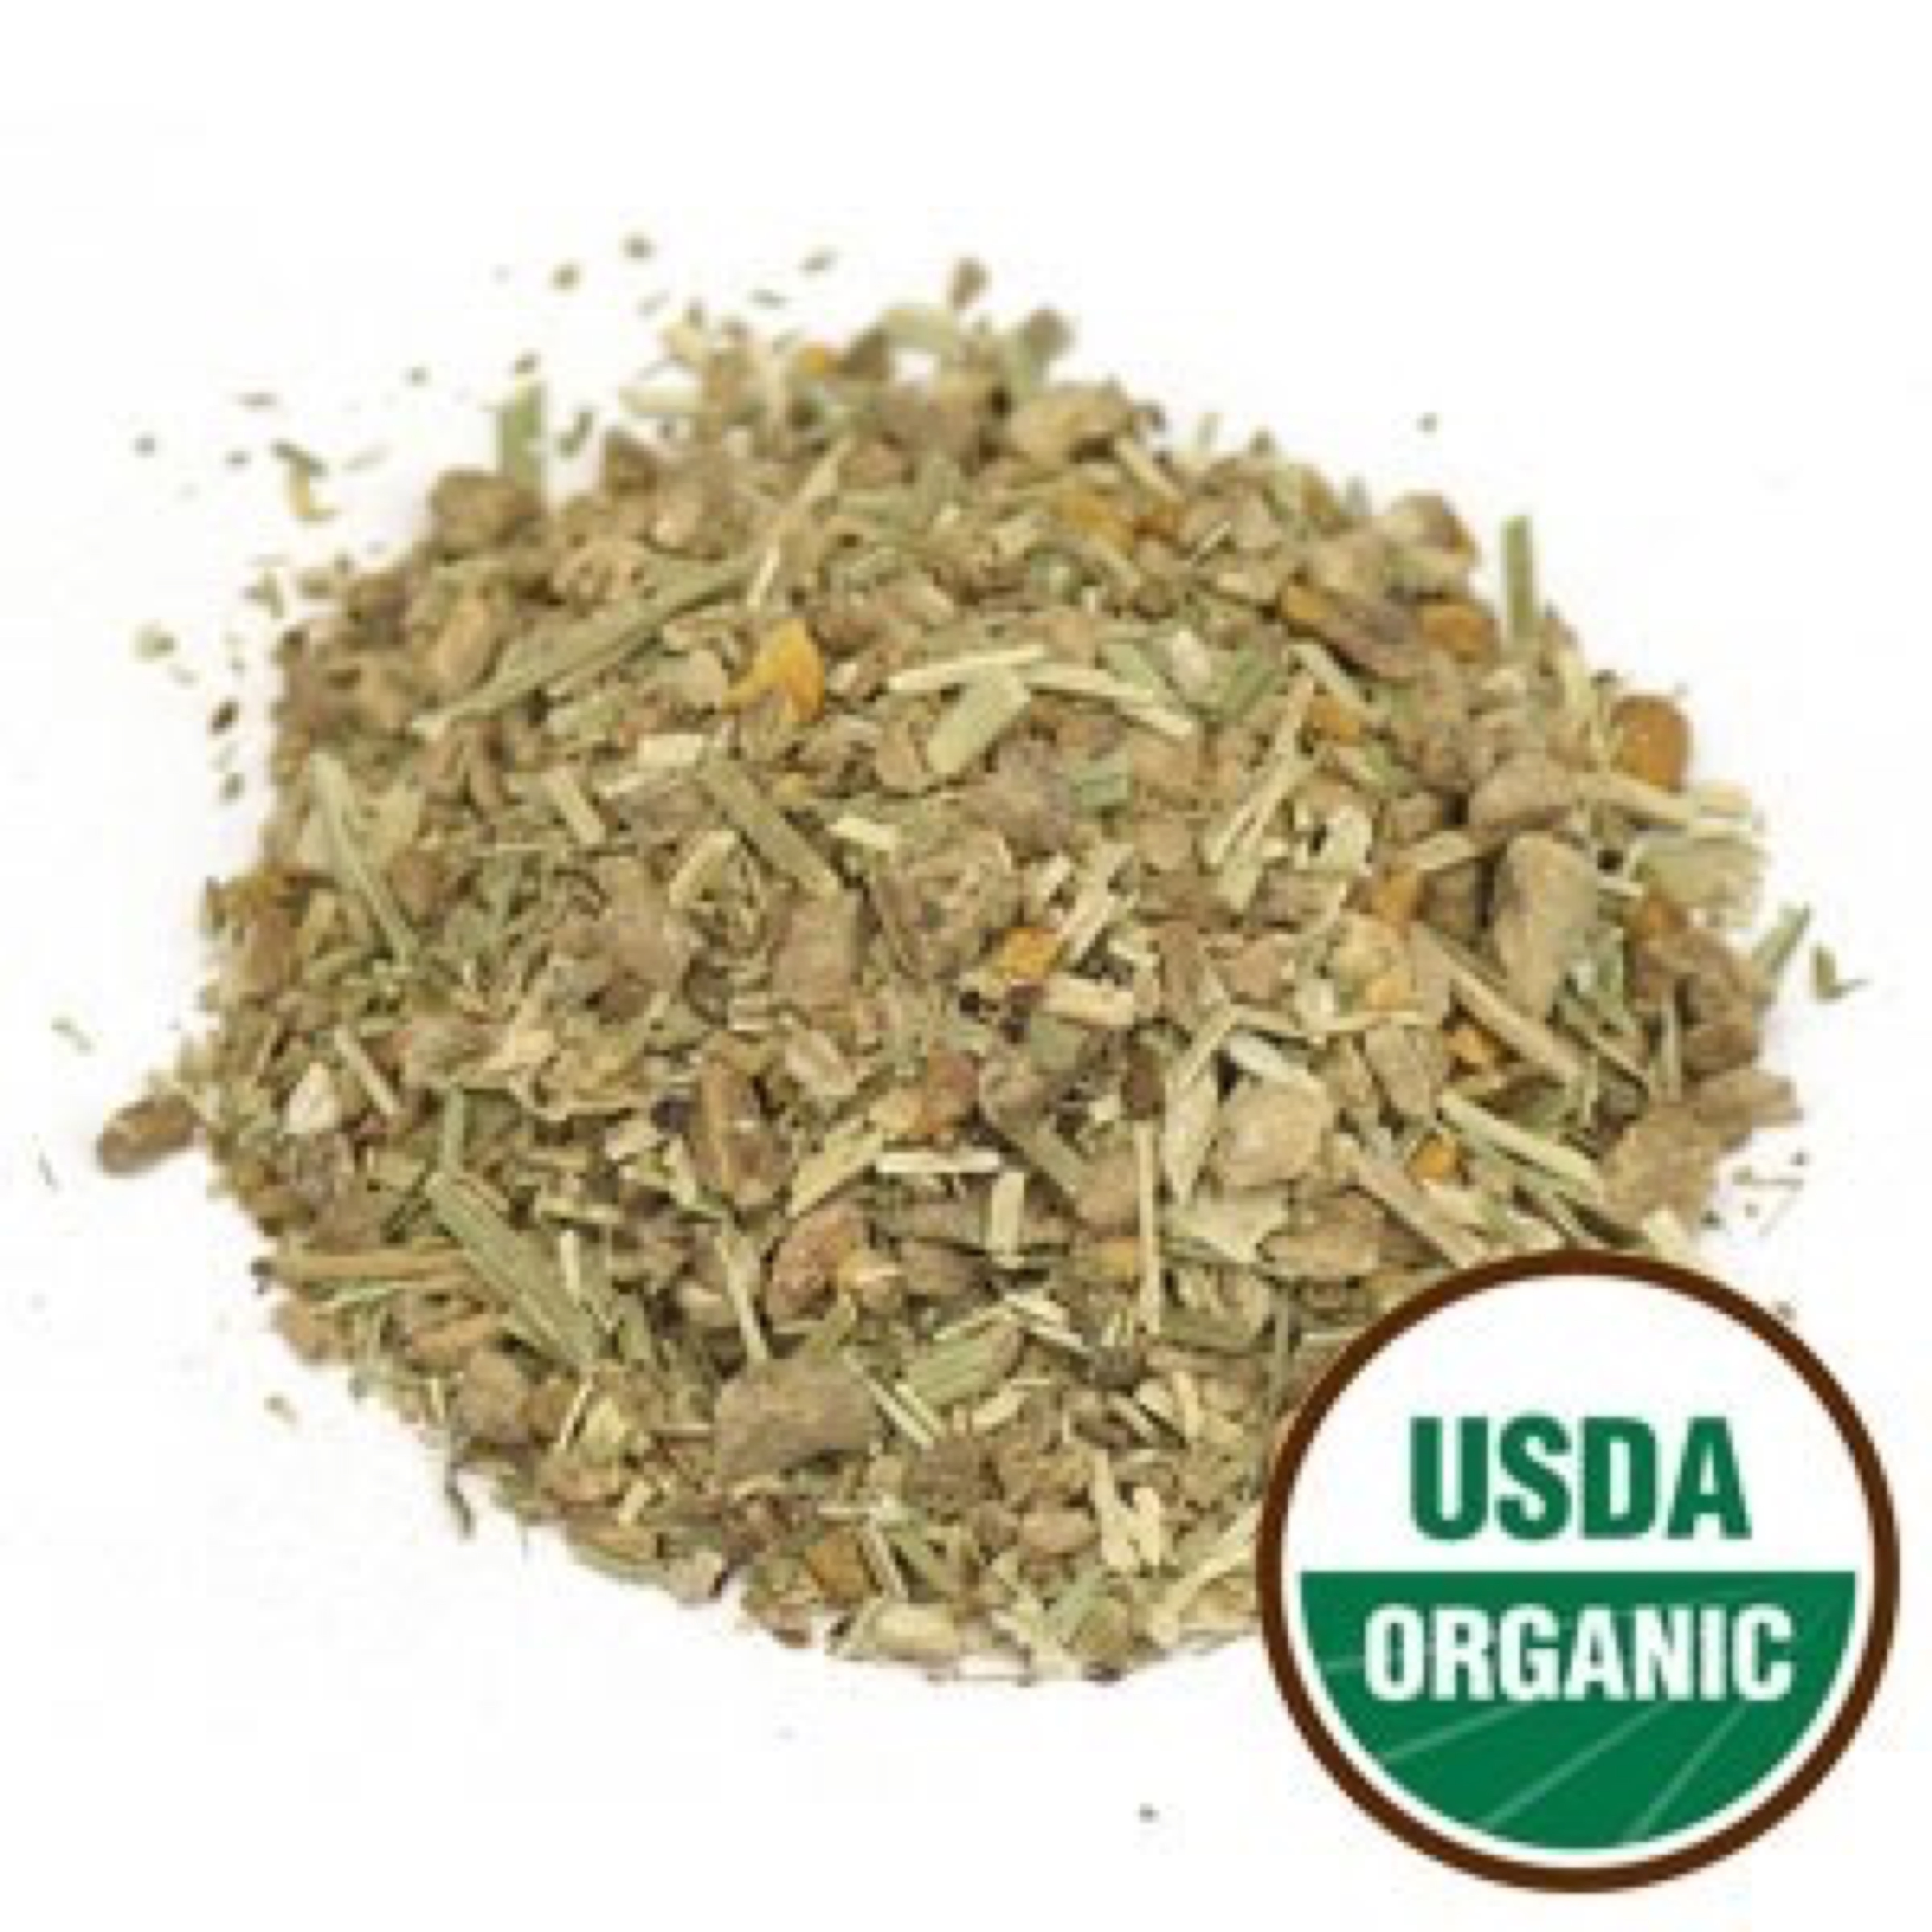

Essiac Tea Organic Herbal

Essiac Tea is a timeless and traditional blend of potent herbs that have historically been used to promote one's health and well-being.

Ingredients: Organic burdock root, organic sheep sorrel herb, organic slippery elm bark, and organic (Turkey) rhubarb root.

Warning: Pregnant women, consult your physician. Should use only stainless steel utensils when preparing this tea.

NOTICE: This product contains Rhubarb Root (Rheum palmatum). Read and follow directions carefully. Do not use if you have or develop diarrhea, loose stools, or abdominal pain because Rhubarb Root may worsen these conditions and be harmful to your health. Consult your physician if you have frequent diarrhea or if you are pregnant, nursing, taking medication, or have a medical condition. Individuals with a history of kidney stones should use this herb cautiously.

Daily serving size: 4 oz

Directions:

To prepare Essiac Tea:

Boil 1 gallon fresh spring water or distilled water in a stainless steel pot.

Stir in 4 oz of tea (by weight *), cover pot.

Boil 10 minutes.

Remove from heat and stir. Cover and let sit for 12 hours at room temperature.

Stir, cover, and bring to a boil. Remove from heat.

Strain through a fine mesh colander. Funnel liquid into clean amber glass bottle and cap. Tighten cap after cooling.

Refrigerate. Mixture will stay fresh for 2-3 weeks if refrigerated.

* If you are unable to weigh 4 oz of tea, you can use the following conversions:

-For Organic and Conventional Essiac Teas: 4 oz is approx. 275 ml or 1 1/16 cup.

-For Organic Trinity Essiac Tea: 4 oz is approx. 180 ml or 3/4 cup.

Directions for drinking:

Shake herbal tea to mix well. Add 2 fl oz tea to equal amount (2 fl oz) boiled fresh spring or distilled water.

Drink 4 fl oz daily on an empty stomach, preferably before bedtime.

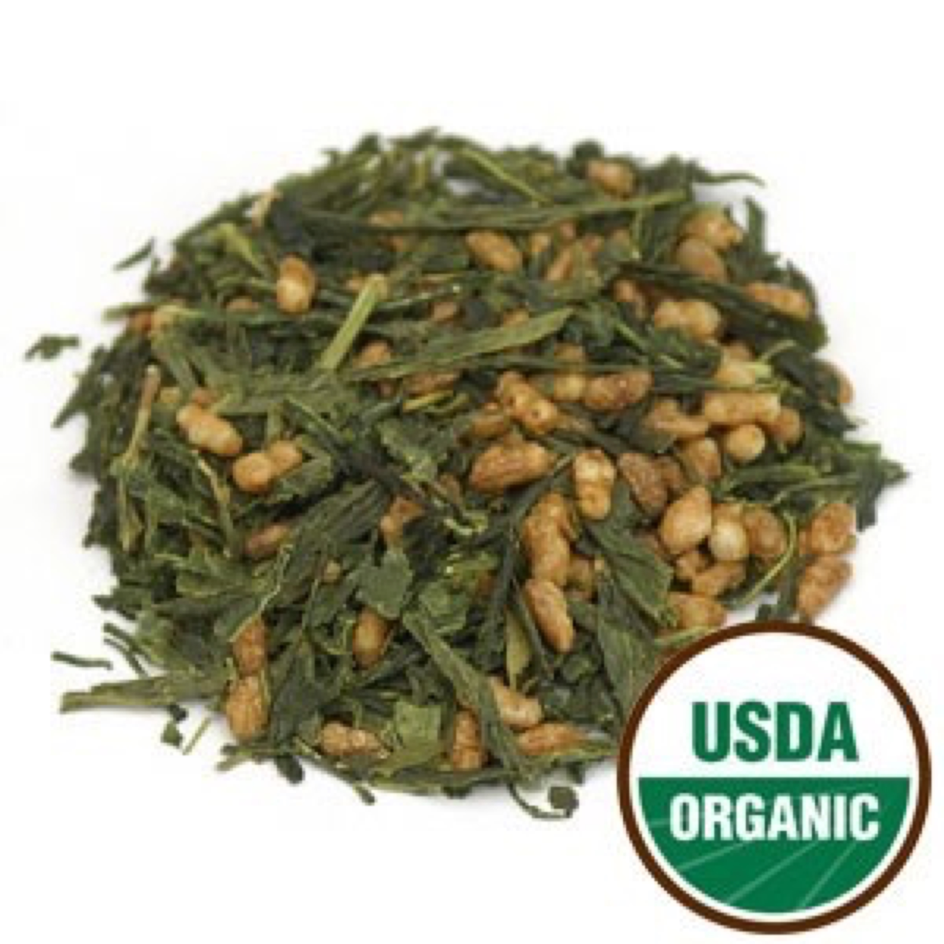

Genmaicha Tea Organic Herbal

A traditional combination of freshly harvested green tea leaves with roasted brown rice creating a mild, toasty aroma and warm, nutty flavor. The soothing taste of Spring in the leaves, and the nutty flavor and aroma of roasted grain that’s reminiscent of Fall, complement and enliven each other. A most delicious tea served hot or cold, it’s great for early dining and well-suited for afternoon dishes.

Ingredients: Organic Green Tea (Camellia sinensis) and Organic Roasted Brown Rice (Oryza sativa).

Daily serving size: Pour 8 oz of simmering water (185-195° F preferred) over 1 tsp. of tea. Steep 3-4 minutes.

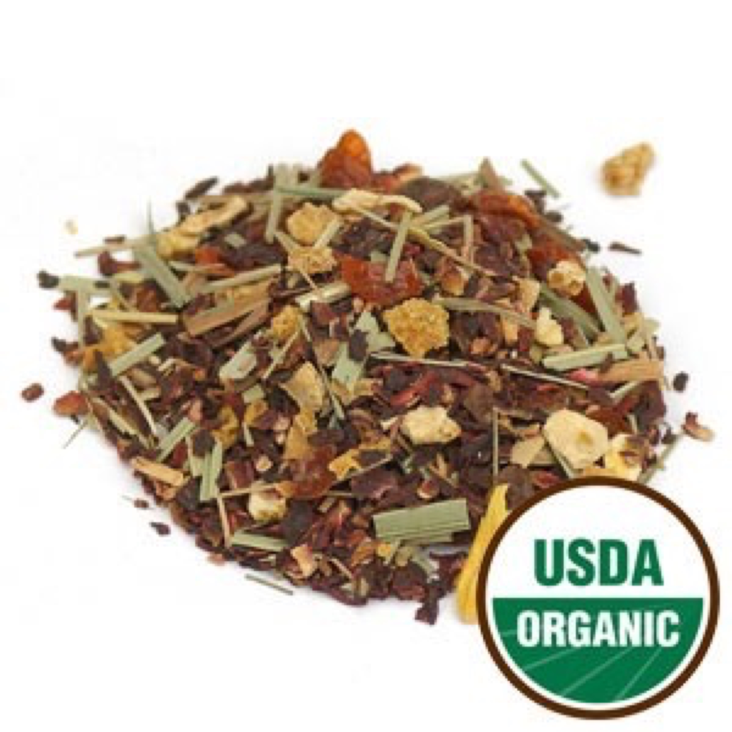

Hibiscus Heaven Tea Organic Herbal

Tropical hibiscus and rosehips give this tea a high Vitamin C content. While blended with the citrus flavors of orange and lemon, together all of these herbs and spices produce a deliciously refreshing citrus herbal tea. It can be tasty served both hot or as the perfect summer iced or sun tea. Caffeine-Free.

Ingredients: Organic hibiscus flower, organic rosehips, organic orange peel, organic lemongrass, organic lemon peel, and organic lemon oil.

Daily serving size: Pour 8-12 oz of boiling water (212° F) over 1 tsp. of tea. Steep 3-4 minutes.

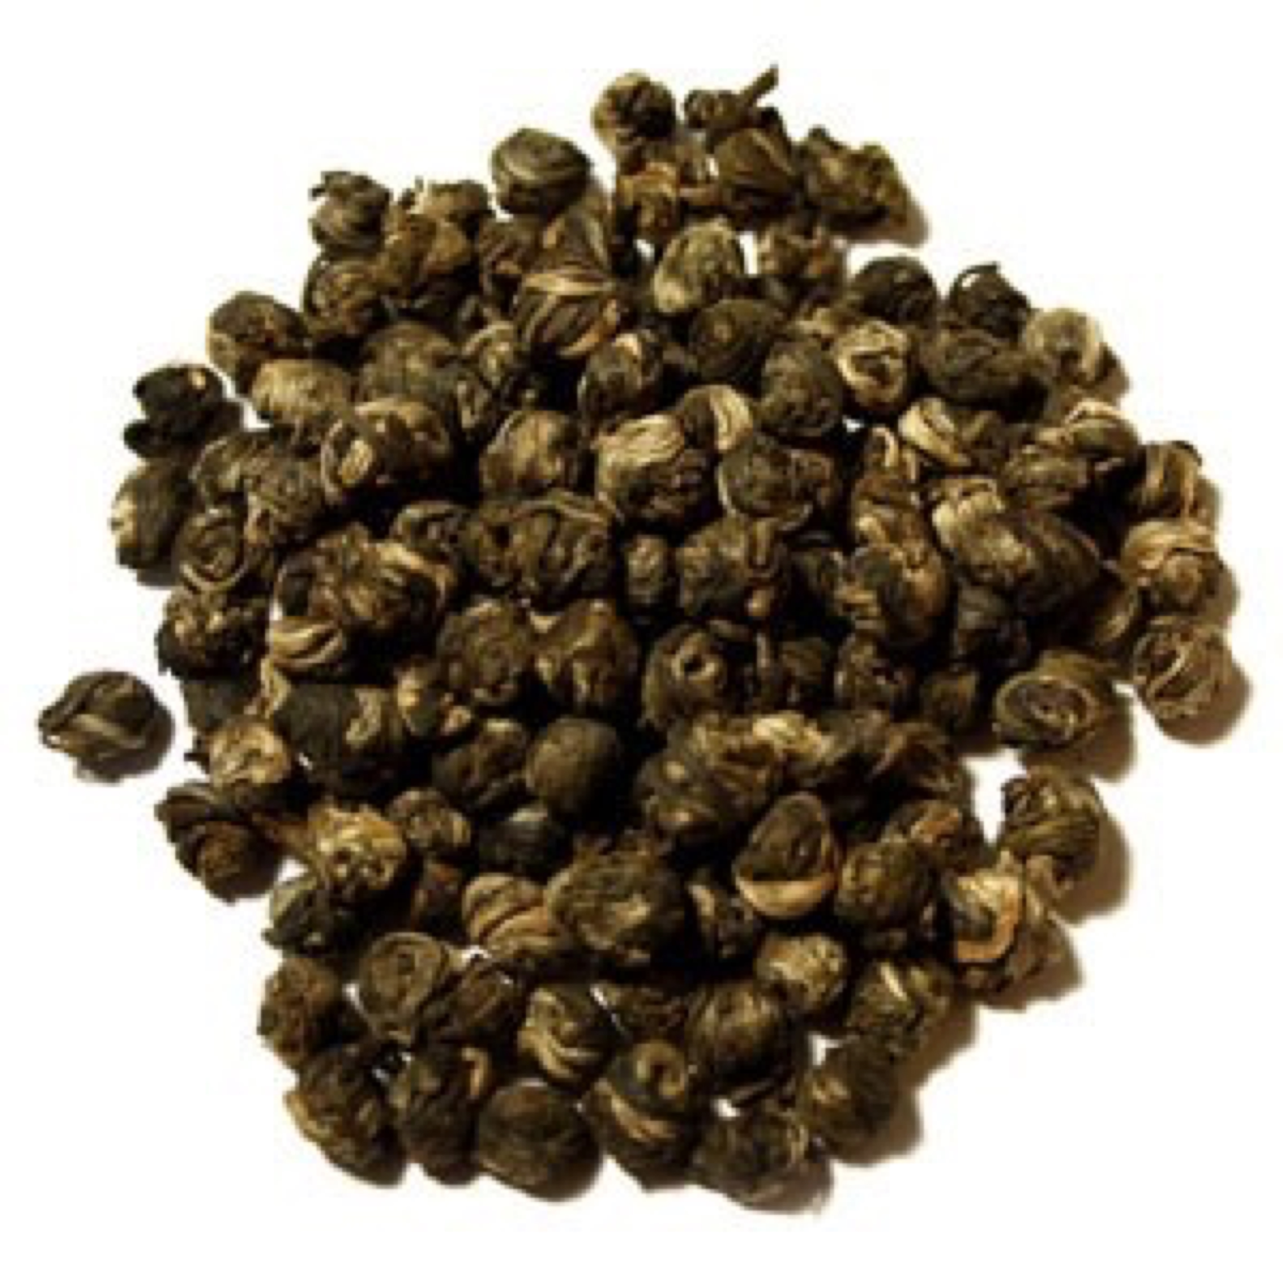

Jasmine Pearls Tea Organic Green

This delectable tea is made with green tea leaves with silver buds, and they are hand rolled into tight pearls and infused with jasmine flowers. Each pearl becomes saturated with the jasmine fragrance, producing a richly aromatic and smooth cup of tea.

Ingredients: Organic green tea scented with organic jasmine flowers.

Daily serving size: Pour 8-12 oz of simmering water (180° F preferred) over 1 tsp. of tea. Steep 2-3 minutes.

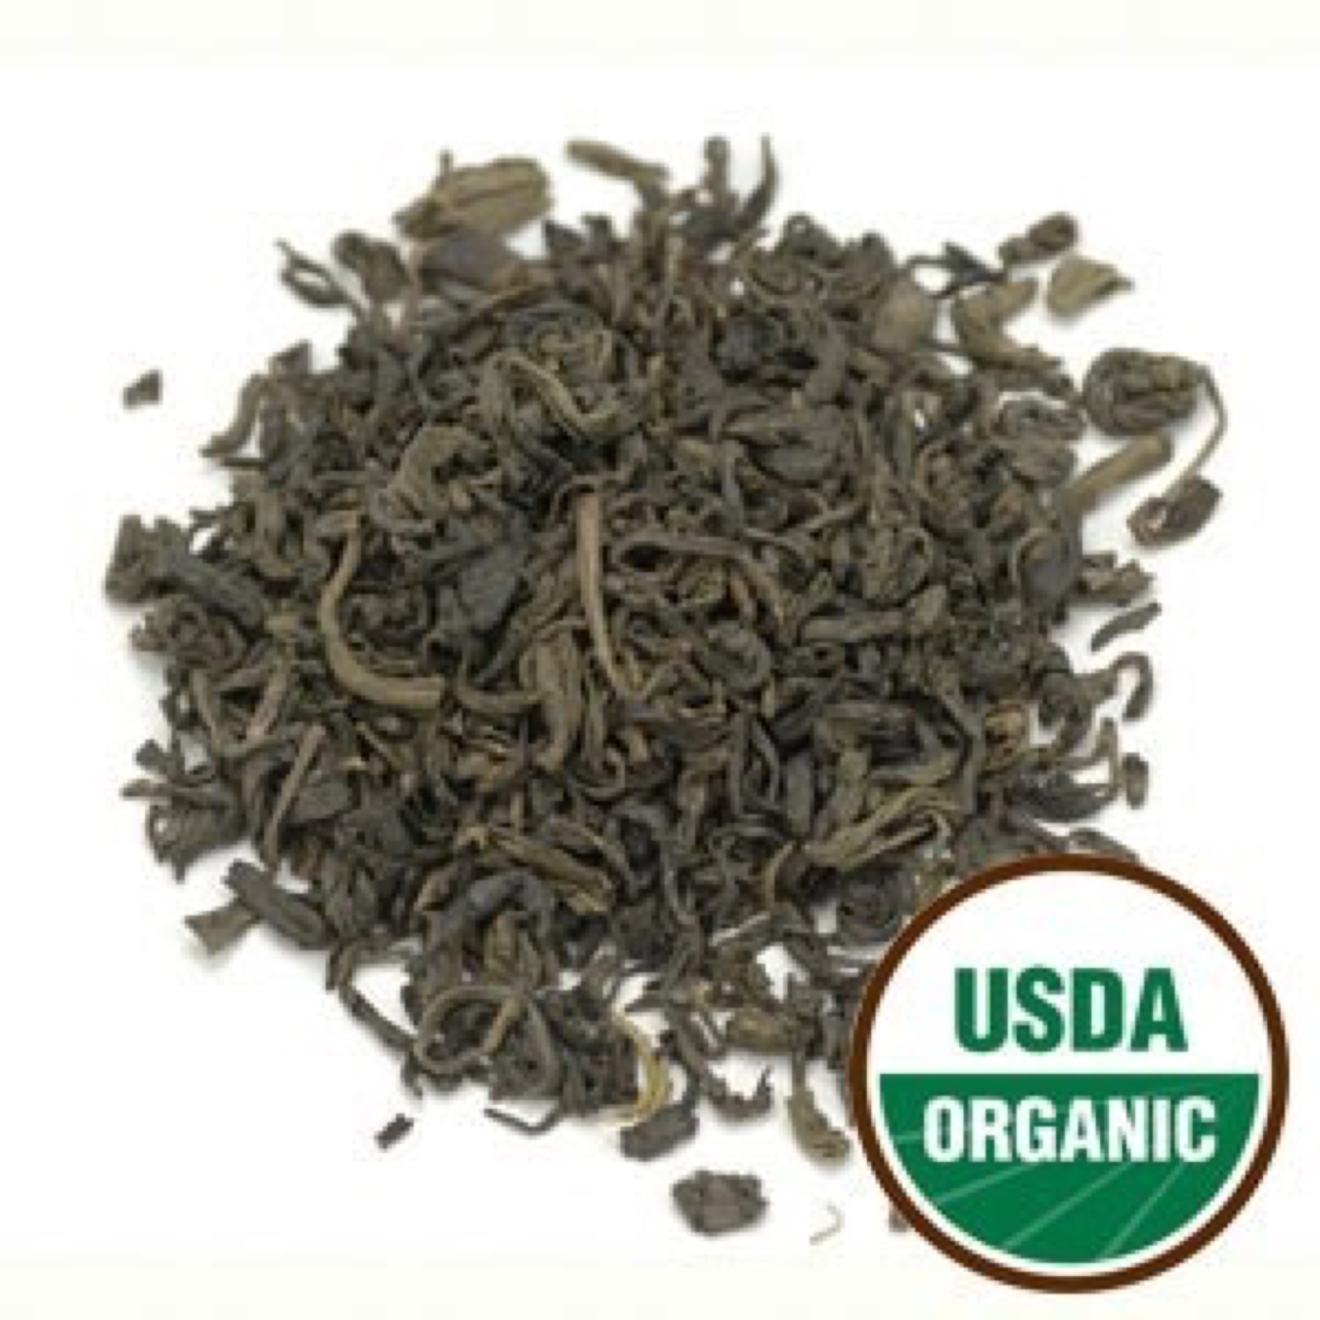

Jasmine Tea Organic Green

This Organic Chinese Green Tea is combined with jasmine, creating a fragrant combination. The green tea leaves are dried with hot air, and fresh jasmine petals are placed in front of the fans, thus the tea absorbs the jasmine fragrance. This tea will produce a cup that has a floral aroma and flavor with a liquor that is lightly sweet and very smooth, making this tea a sensual pleasure to drink.

Ingredients: Organic green tea scented with organic jasmine flowers.

Daily serving size: Pour 8-12 oz of simmering water (180° F preferred) over 1 tsp. of tea. Steep 2-3 minutes.

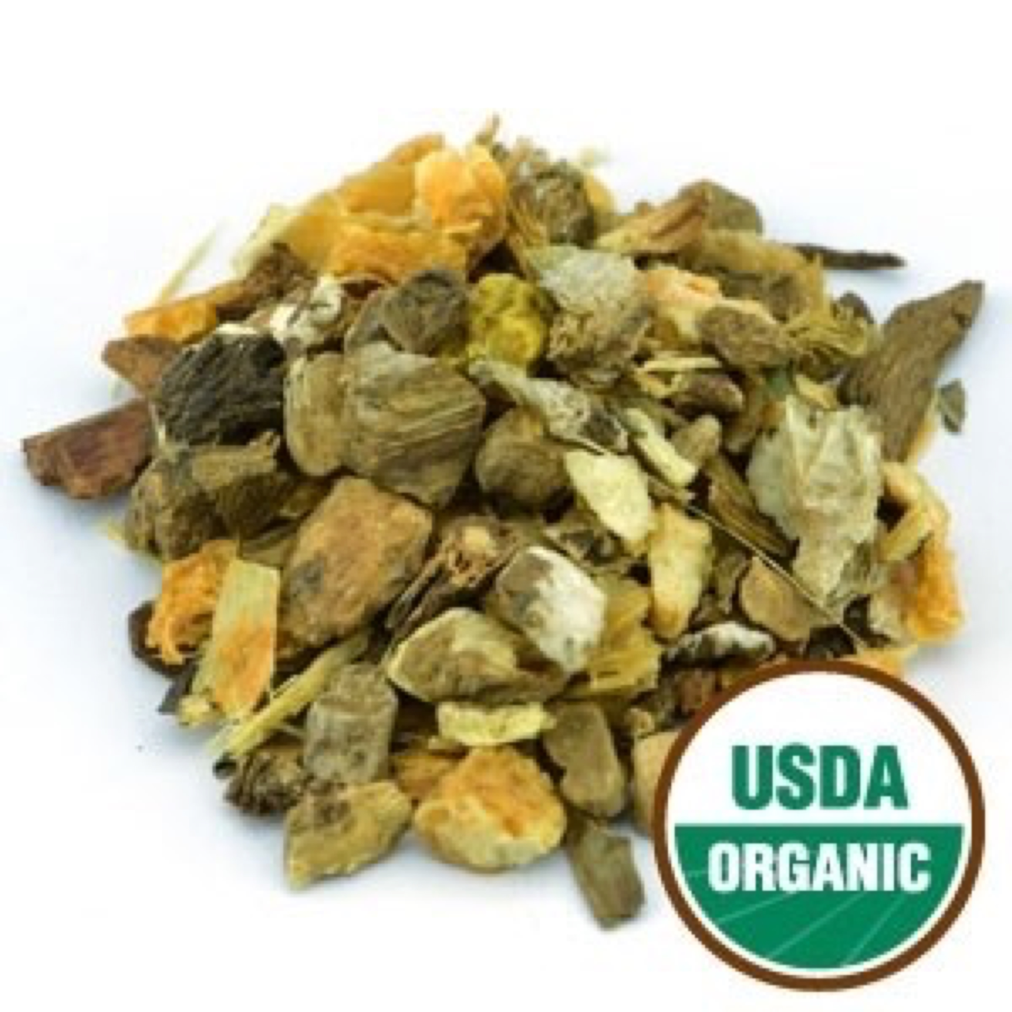

Joint Support Tea Organic Herbal

This tea is formulated to help support joint health naturally with a powerful blend of herbs and spices. Caffeine-Free.

Ingredients: Organic devil's claw root, organic burdock root, organic dandelion root, organic licorice root, organic turmeric root, organic cinnamon, organic orange peel, and organic peppermint leaf.

Warning: Use with caution in persons with gastric or duodenal ulcers.

Daily serving size: Pour 8-12 oz of boiling water (212° F) over 1 tsp. of tea. Steep 3-4 minutes.

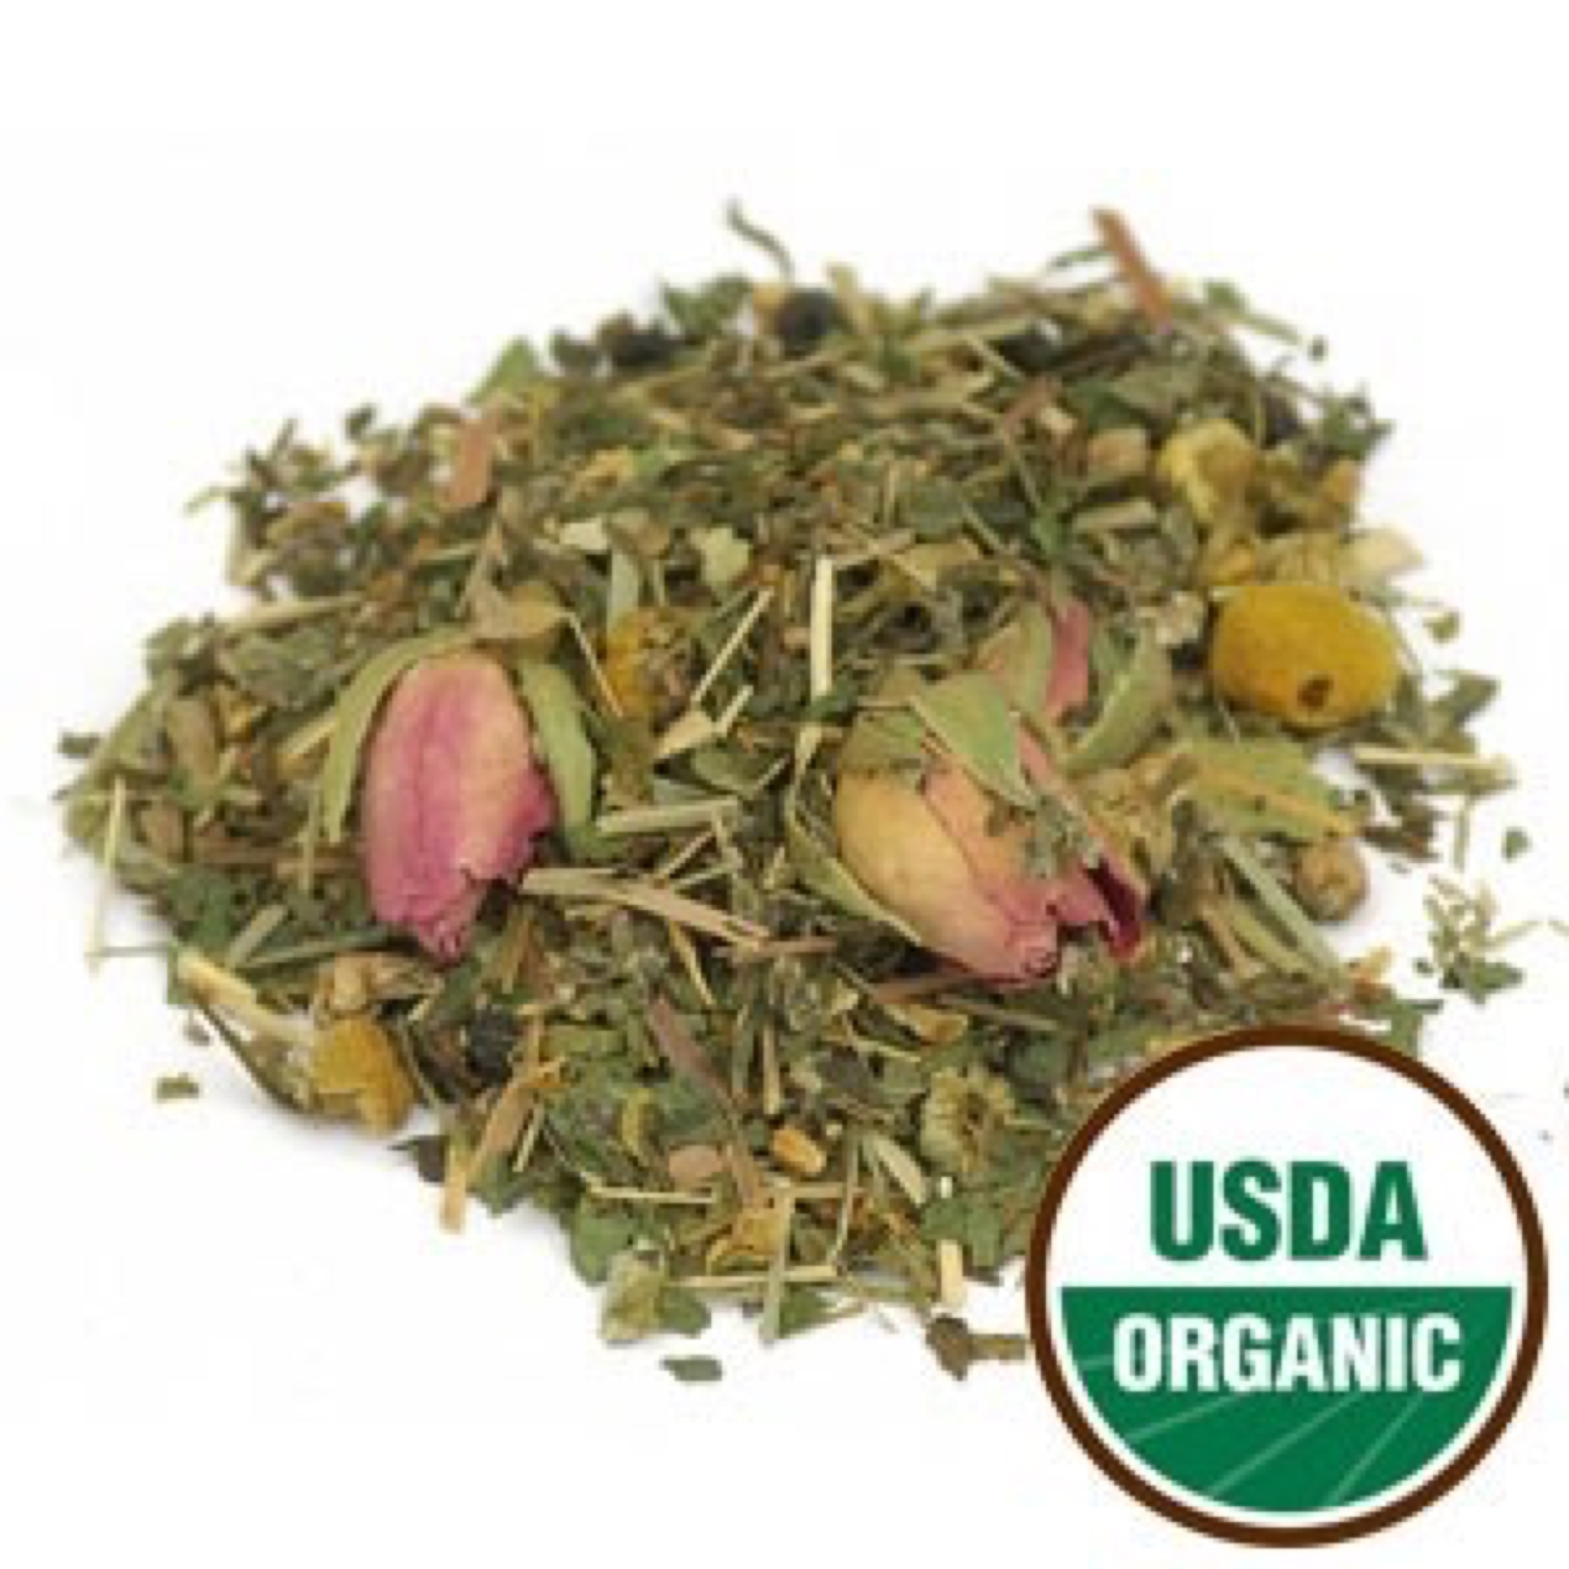

Lazy Daze Tea Organic Herbal

This tea is a tasteful blend of mint and citrus fruit flavors, blended with aromatic flowers and berries. It’s the perfect beverage for relaxing, whether it’s the end of a hard day or you just want to enjoy a lazy afternoon. Caffeine-Free.

Ingredients: Organic spearmint leaf, organic lemongrass, organic elder berry, organic red rose buds and petals, organic linden flower and leaf, organic chamomile flower, organic raspberry leaf, and organic orange peel.

Daily serving size: Pour 8-12 oz of boiling water (212° F) over 1 tsp. of tea. Steep 3-4 minutes.

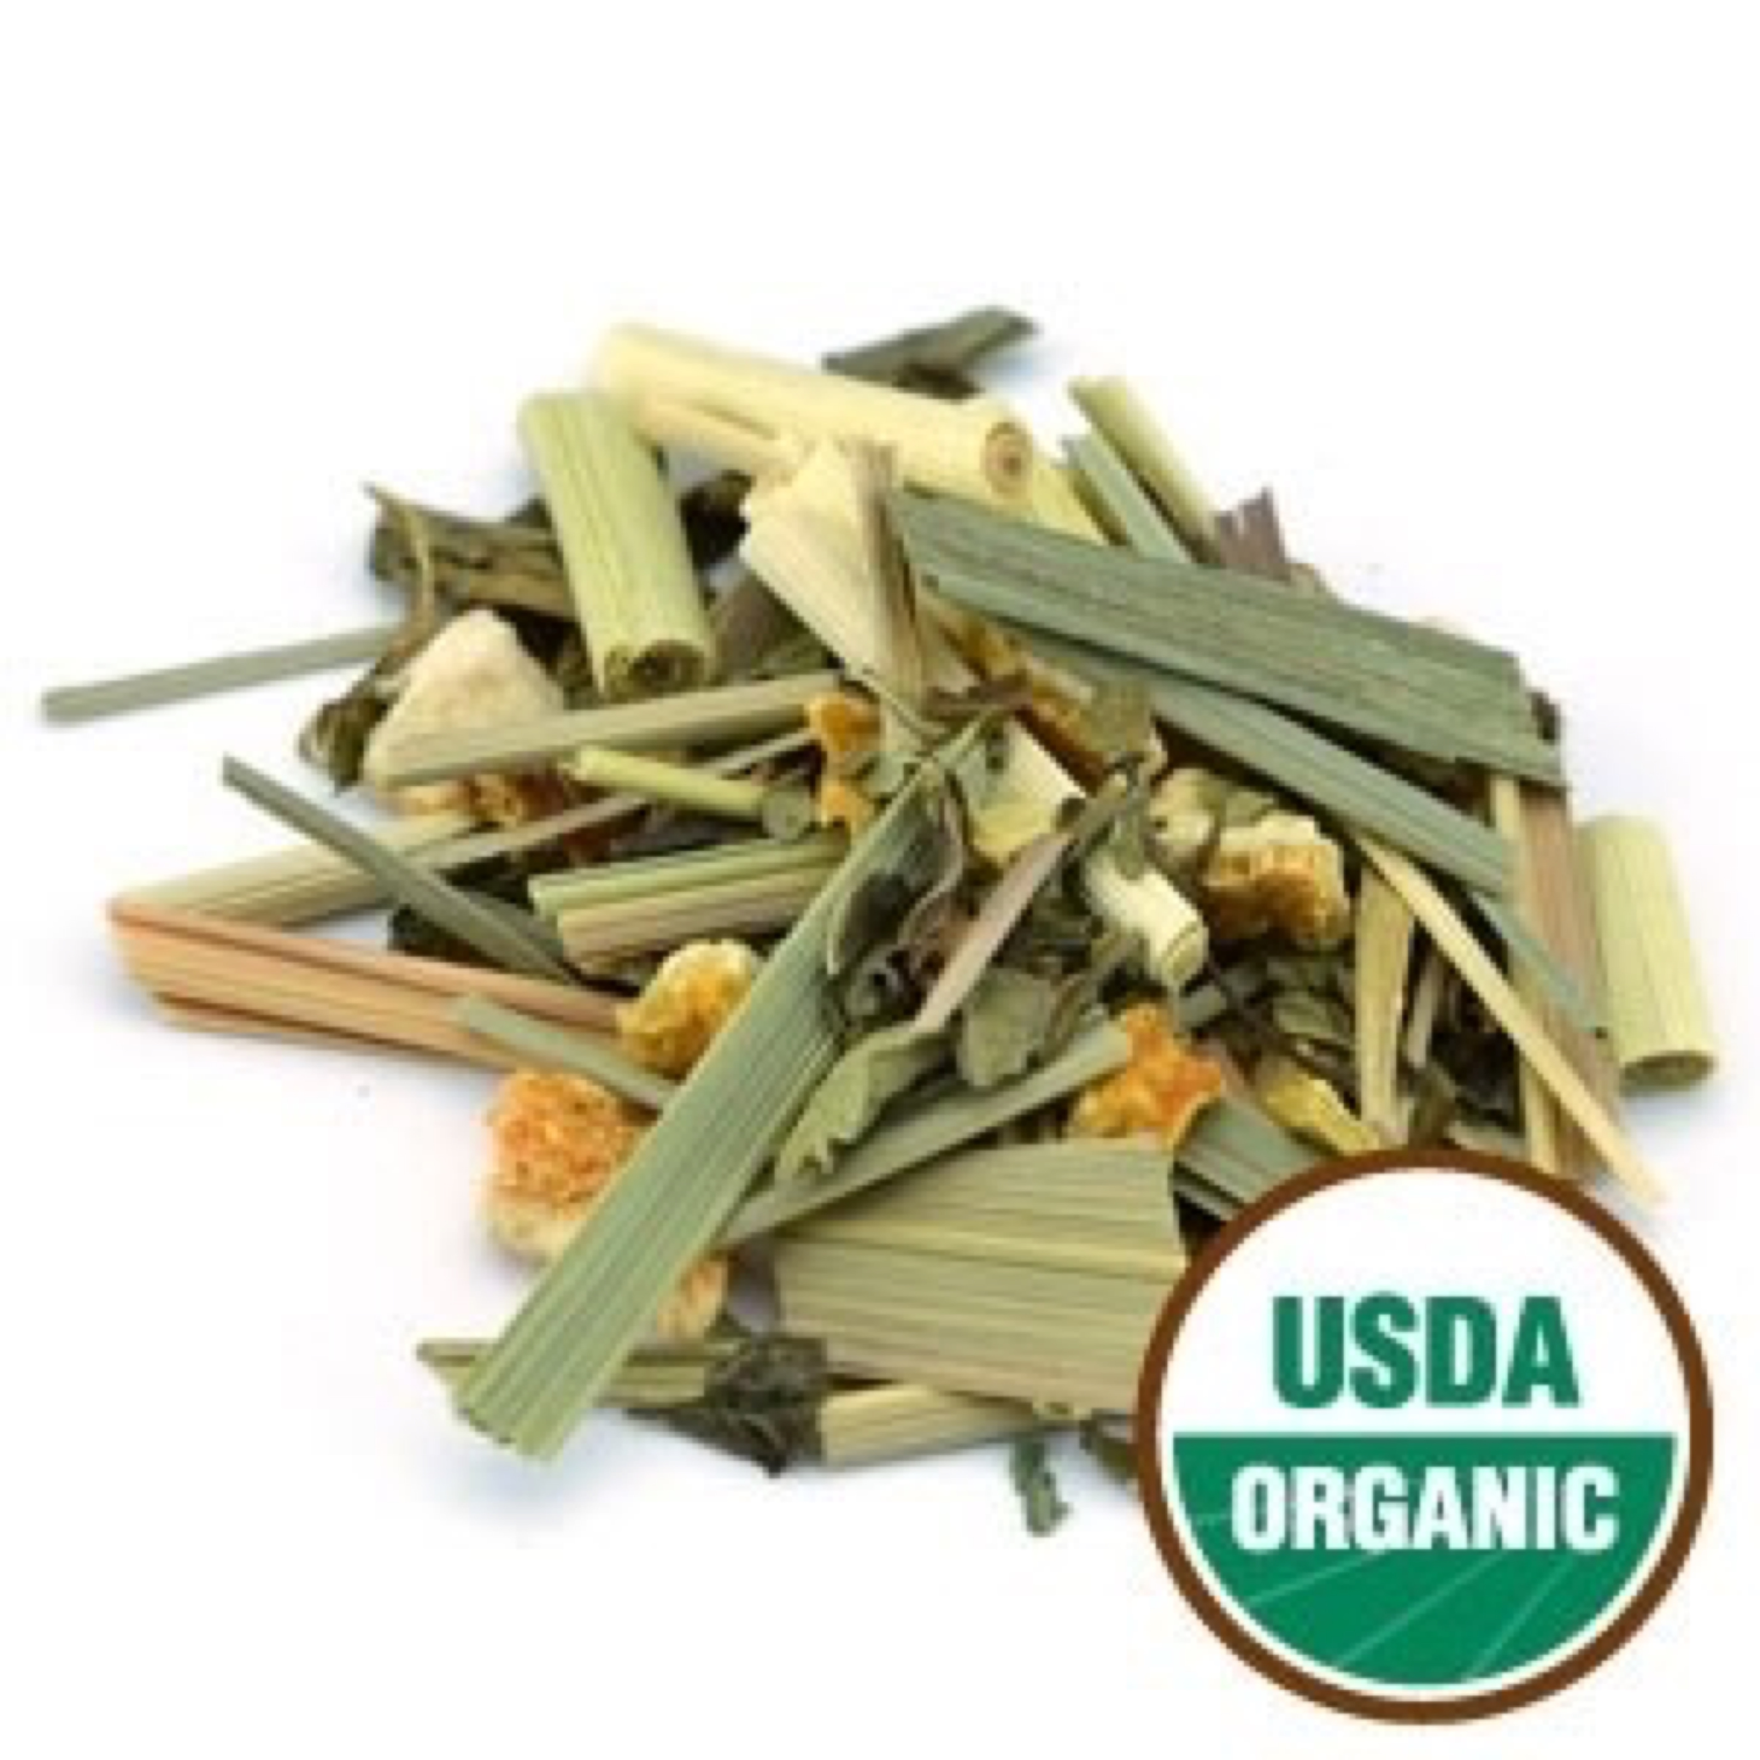

Lemon Ginger Tea Organic Herbal

This uplifting tea is especially soothing after a long, stressful day. It has the refreshing taste of lemon, the soothing and calming effects of ginger and peppermint, along with a delicious hint of licorice. It is the perfect tea to drink during the Winter season, and it’s also great for iced tea. Caffeine-Free.

Ingredients: Organic lemongrass, organic ginger root, organic lemon peel, organic peppermint leaf, organic licorice root, and organic stevia leaf.

Daily serving size: Pour 8-12 oz of boiling water (212° F) over 1 tsp. of tea. Steep 3-4 minutes.

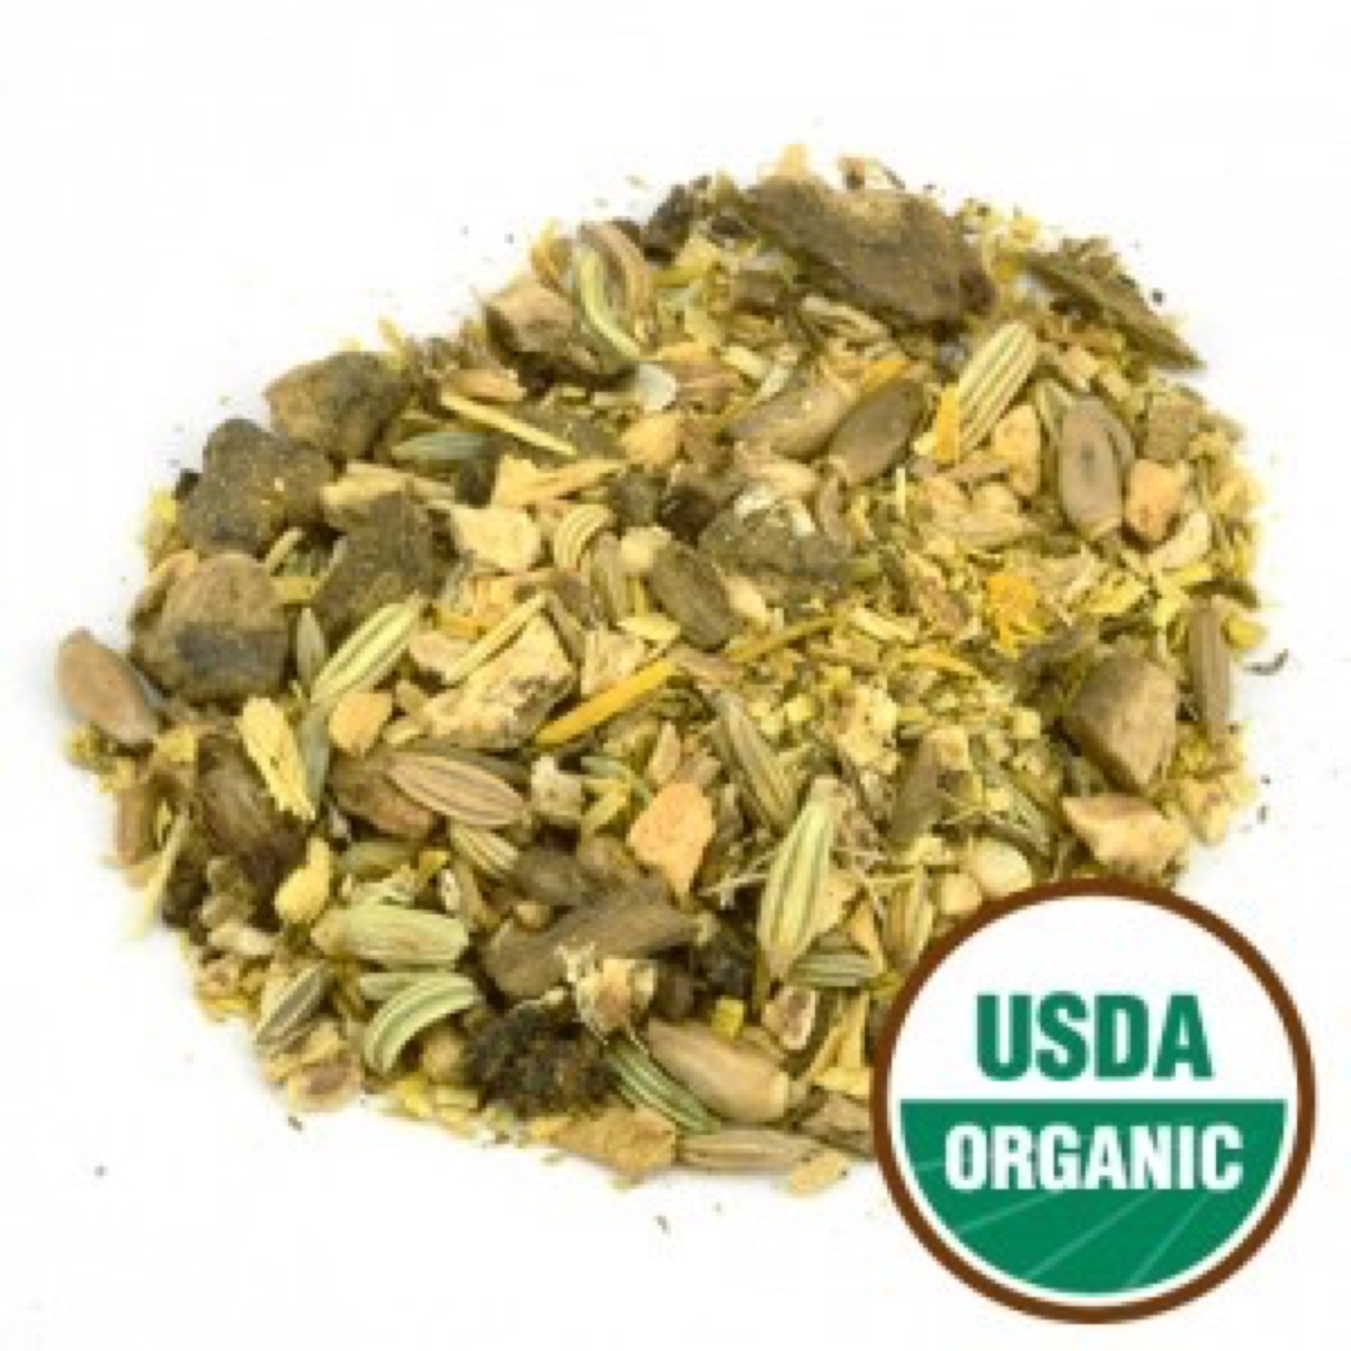

Liver Cleanse Tea Organic Herbal

The liver is an important organ that serves as the gateway for waste that the body accumulates through the environment, stress, and certain foods. We specifically designed this herbal blend to help support proper function of the liver. Caffeine-Free.

Ingredients: Organic burdock root, organic dandelion root, organic milk thistle seed, organic barberry root, organic fennel seed, organic licorice root, and organic ginger root.

Daily serving size: Pour 8-12 oz of boiling water (212° F) over 1 tsp. of tea. Steep 3-4 minutes.

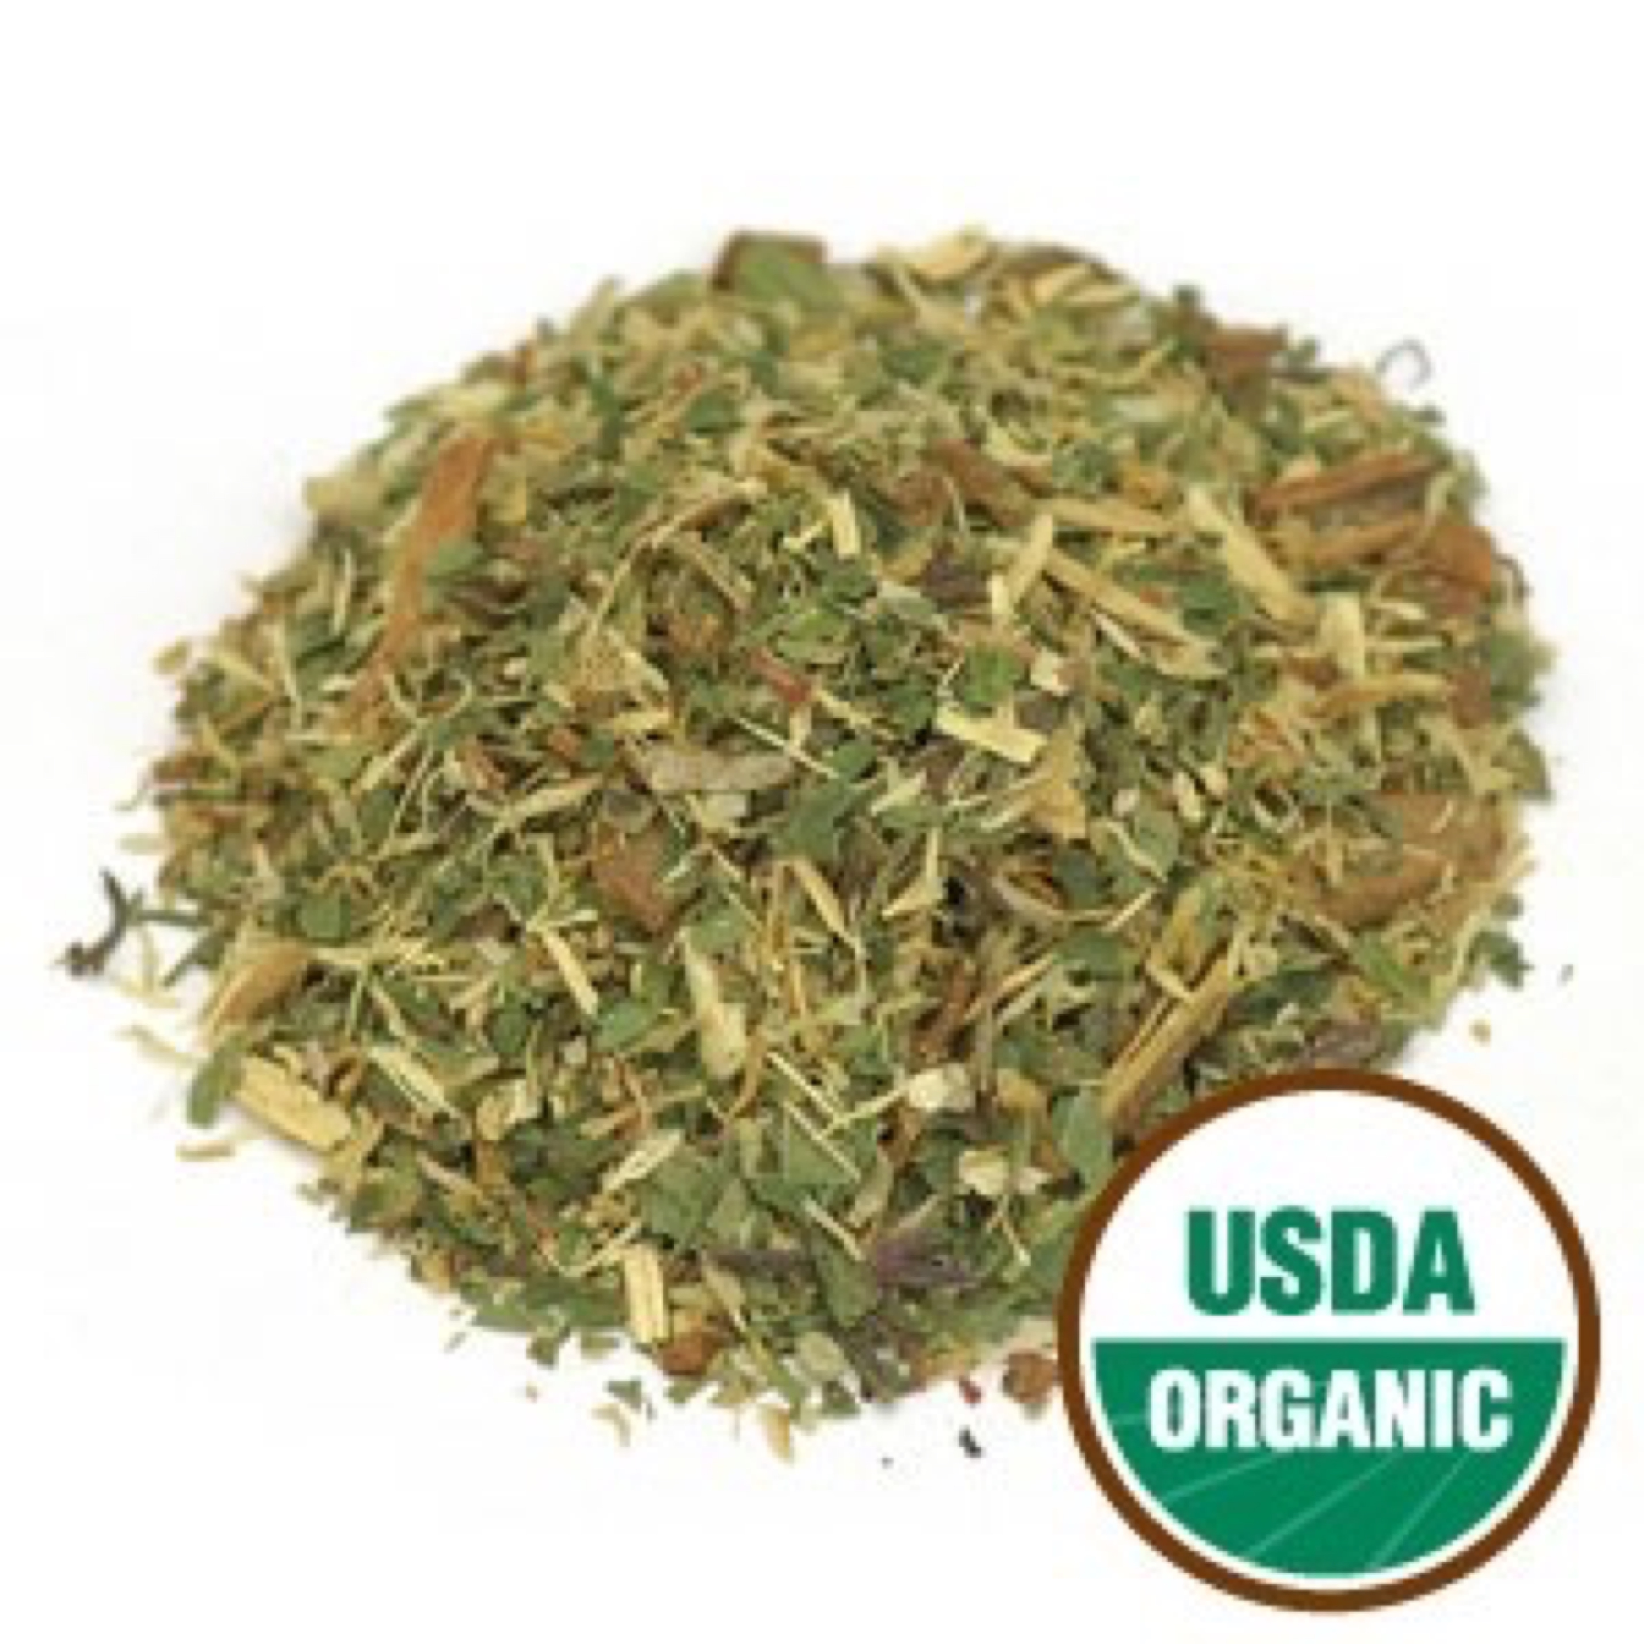

Long Life Tea Organic Herbal

This tea blend is especially comforting after a long stressful day. The ingredients are skillfully balanced between Yin and Yang, making it a popular tea for modern lifestyles, with a refreshingly minty flavor. Caffeine-Free.

Ingredients: Organic peppermint leaf, organic licorice root, organic cinnamon, organic chrysanthemum flowers and organic honeysuckle flowers.

Daily serving size: Pour 8-12 oz of boiling water (212° F) over 1 tsp. of tea. Steep 3-4 minutes.

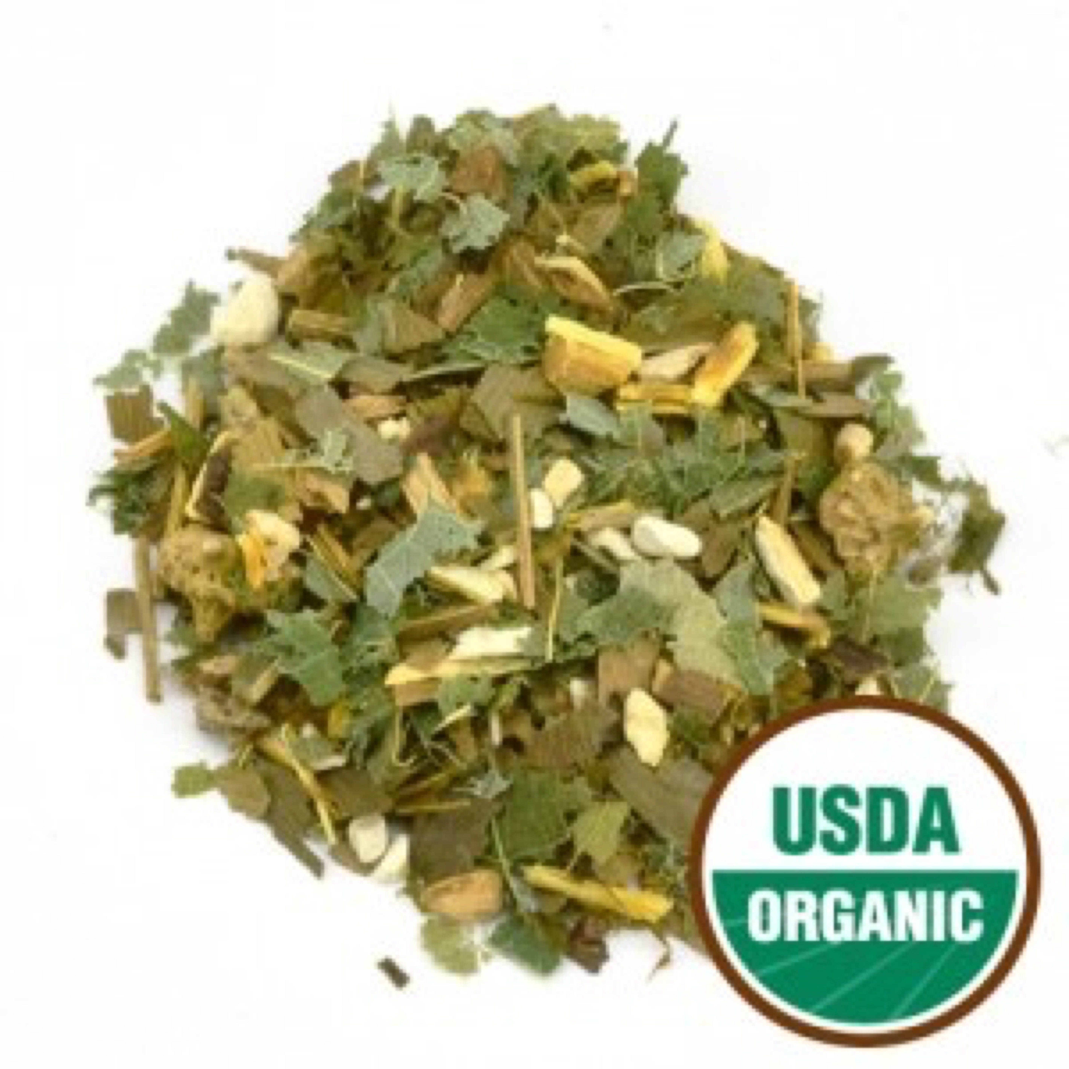

Male Support Tea Organic Herbal

This formula is specifically designed for men’s health. It’s a blend of herbs to help promote vitality, energy, stamina, strength and proper function of the male reproductive system. Caffeine-Free.

Ingredients: Organic ashwagandha root, organic ginkgo leaf, organic horny goat weed, organic licorice root, and organic tribulus fruit.

Daily serving size: Pour 8-12 oz of boiling water (212° F) over 1 tsp. of tea. Steep 3-4 minutes.

**Packaging:** To preserve freshness, aroma, and potency, our herb and teas are packaged in a polyfoil bag with a re-sealable zipper closure, protecting the contents from light exposure and moisture.